**VCA**

**(Virtual Computing Architecture)**

**Three Tier Architecture**

AWS Deployment

**Report on the Three-Tier Architecture Project**

**Introduction**

The three-tier architecture is a widely adopted design framework in software development, particularly for web applications. This project focuses on deploying a secure, scalable, and high-performance three-tier architecture on Amazon Web Services (AWS). The architecture separates the application into three distinct layers: the presentation layer (web tier), the application layer (logic tier), and the data layer (database tier). This modular approach ensures better maintainability, scalability, and fault tolerance. The following report outlines the project’s goals, implementation strategies, functional and non-functional requirements, and the AWS services used.

**Purpose and Scope**

The primary objective of this project is to deploy a robust web application using AWS services while adhering to industry best practices. The system is designed to provide:

* **High Availability:** Using AWS’s Multi-AZ deployments and load balancing.
* **Security:** Enforcing strict role-based access controls, encryption, and secure communication protocols.
* **Scalability:** Ensuring the system can handle growing workloads through auto-scaling mechanisms.
* **Performance Efficiency:** Optimizing response times under varying user loads.

The three-tier architecture consists of:

1. **Presentation Tier (Web Tier):** This layer handles user interaction through a responsive web interface hosted on AWS EC2 instances.
2. **Application Tier (Logic Tier):** The business logic and API requests are processed in this layer, ensuring secure interactions between users and the database.
3. **Data Tier (Database Tier):** Stores and retrieves structured data using Amazon Aurora MySQL with high availability and fault tolerance.

**System Overview**

The project leverages AWS-managed services to build a highly resilient and cost-efficient architecture:

**Web Tier (Presentation Layer)**

* Hosted on Amazon EC2 instances running Nginx to serve the web application.
* An external Application Load Balancer (ALB) evenly distributes incoming traffic.
* Static assets such as images, CSS, and JavaScript files are served from Amazon S3 using CloudFront for faster content delivery.
* Communication is secured using SSL/TLS certificates managed by AWS Certificate Manager (ACM).

**Application Tier (Logic Layer)**

* Deployed on private EC2 instances or AWS Lambda functions to process user requests.
* API Gateway manages RESTful endpoints for scalability and security.
* Internal ALB distributes traffic between application-tier instances.
* Messaging services like Amazon SNS or SQS are integrated for notifications and asynchronous processing.

**Database Tier (Data Layer)**

* Amazon Aurora MySQL is used for storing structured data, ensuring consistency and high availability through Multi-AZ replication.
* Regular automated backups and snapshots are configured for data recovery.
* Encryption at rest is implemented using AWS Key Management Service (KMS), and in transit using SSL/TLS.

**Functional Requirements**

1. **Web Tier:**
   * Serve the front-end application via EC2 instances.
   * Distribute traffic using an Application Load Balancer (ALB).
   * Store and serve static content via Amazon S3.
   * Ensure secure communication through HTTPS.
2. **Application Tier:**
   * Deploy business logic on private EC2 instances.
   * Manage APIs via API Gateway for secure access.
   * Use VPC endpoints for secure communication with the database.
3. **Database Tier:**
   * Utilize Amazon Aurora MySQL for high-performance data storage.
   * Implement automated backups and data encryption.
   * Restrict access to the database using IAM roles and security groups.

**Non-Functional Requirements (NFRs)**

1. **Performance:**
   * Handle up to 500 concurrent users with a response time of less than 200ms.
   * Use Auto Scaling Groups (ASG) to dynamically adjust resources based on traffic.
2. **Security:**
   * Role-Based Access Control (RBAC) using AWS IAM.
   * Multi-factor authentication (MFA) for administrative access.
   * Encrypt data at rest and in transit.
3. **Scalability:**
   * Enable horizontal scaling for the web and application layers.
   * Use Aurora read replicas to handle increased read operations.
4. **Availability:**
   * Achieve 99.9% uptime using Multi-AZ deployments and ALB health checks.
   * Reroute traffic automatically in case of failures.

**AWS Service Integration**

**1. Application Load Balancer (ALB):**

* Distributes incoming traffic across web-tier instances.
* Handles both external and internal traffic routing.

**2. Amazon EC2 Instances:**

* Hosts the web and application layers.
* Configured for high availability with Auto Scaling Groups.

**3. Amazon Aurora MySQL:**

* Provides a reliable, highly available database solution.
* Supports automated backups and failover mechanisms.

**4. AWS CloudFront:**

* Accelerates content delivery by caching static assets closer to users.

**5. AWS Certificate Manager (ACM):**

* Manages SSL/TLS certificates to secure communications.

**6. Amazon Route 53:**

* Routes traffic to the appropriate ALB and provides DNS resolution.

**System Design Constraints**

* The architecture must comply with AWS’s Well-Architected Framework, ensuring reliability, performance efficiency, and cost optimization.
* Deployment is restricted to a Virtual Private Cloud (VPC) for enhanced security.
* Infrastructure as Code (IaC) tools like AWS CloudFormation or Terraform are used for consistent and automated deployments.

**Benefits of the Three-Tier Architecture**

1. **Modularity:** The separation of concerns simplifies maintenance and scaling.
2. **Resilience:** Multi-AZ deployments and load balancing enhance fault tolerance.
3. **Performance Optimization:** Efficient use of AWS services ensures quick response times.
4. **Security:** Role-based access, encryption, and private subnets mitigate risks.
5. **Scalability:** Auto Scaling Groups and Aurora replicas handle varying workloads effectively.

**Challenges and Mitigations**

1. **High Initial Setup Costs:**
   * Optimize costs by leveraging AWS’s free tier and choosing reserved instances for predictable workloads.
2. **Complexity in Configuration:**
   * Use IaC tools like CloudFormation to simplify deployment and configuration.
3. **Data Security Risks:**
   * Enforce strict IAM policies and encryption standards.

**Conclusion**

The deployment of a three-tier architecture using AWS showcases the power of modular design and cloud-based scalability. By leveraging AWS services such as EC2, ALB, and Aurora MySQL, the system achieves high availability, security, and performance efficiency. This architecture is ideal for modern web applications, ensuring that user demands are met without compromising on reliability or security. Future enhancements could involve the integration of serverless components, such as AWS Lambda, to further reduce operational overhead and costs.

1. Create A VPC.

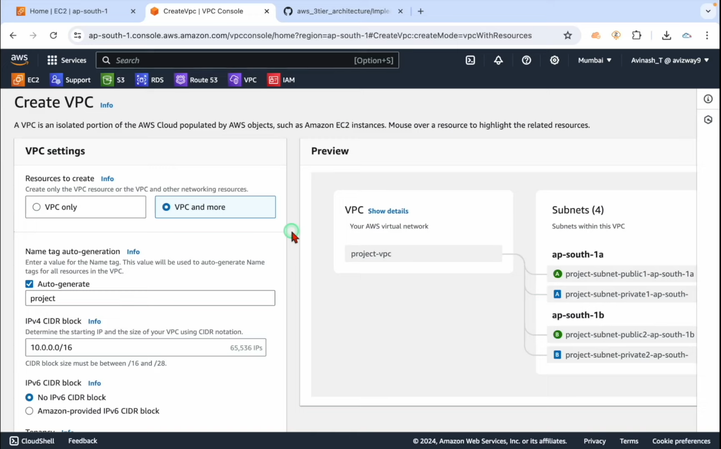

1. Set up the name and Ip address Ip v6 cider block.

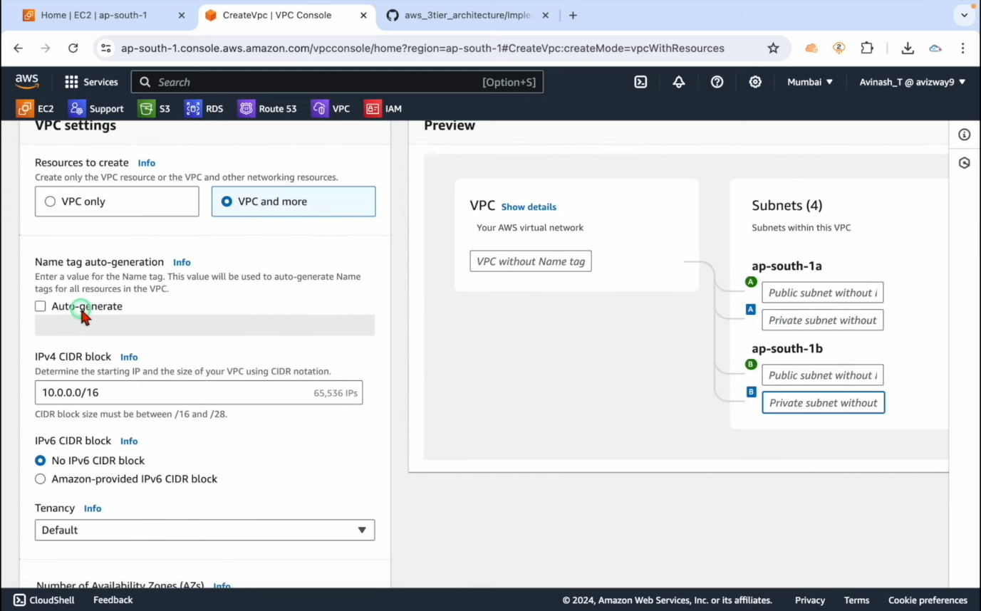

1. Create subnets with 2 availability zones.

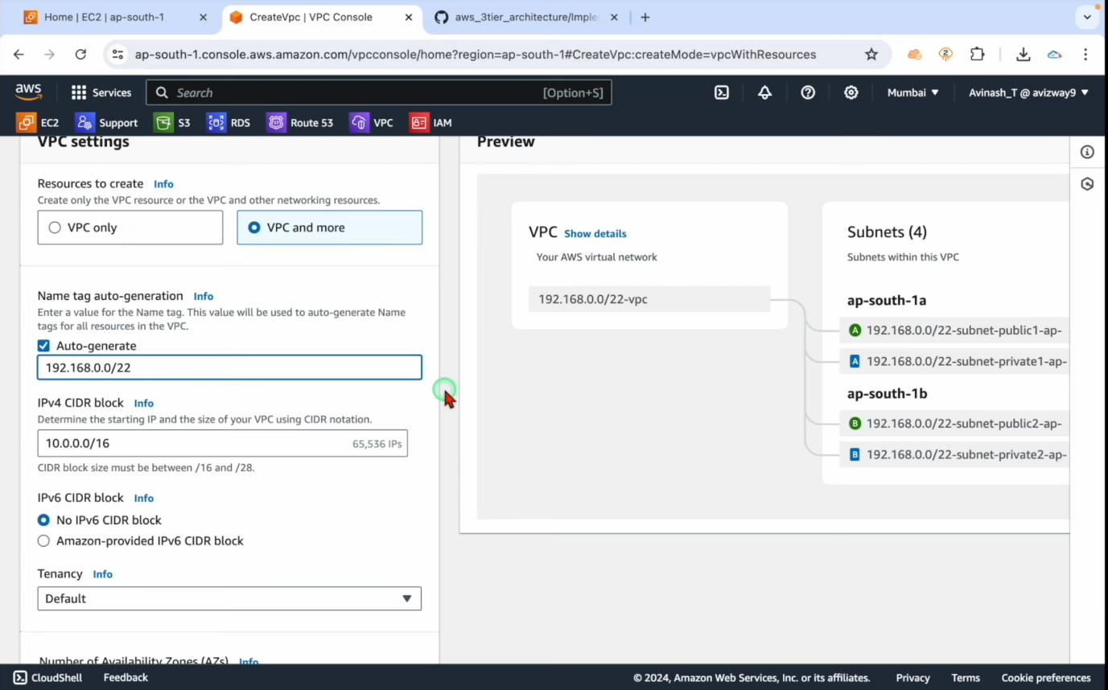

1. Create 4 private and 2 public zones with VPC
2. Allow subnets web tier- Two subnets

App tier- 2 subnets

Database tier – 2 subnets

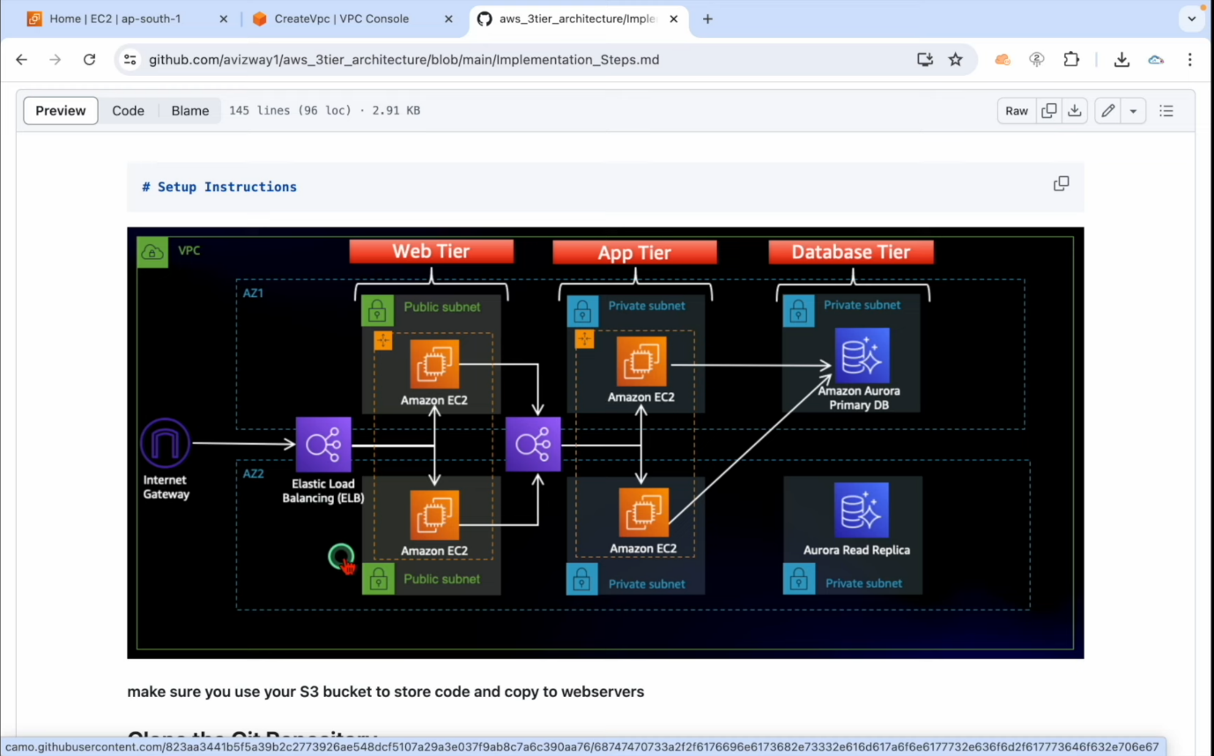

1. Select Nat gateways in (one availability zone).

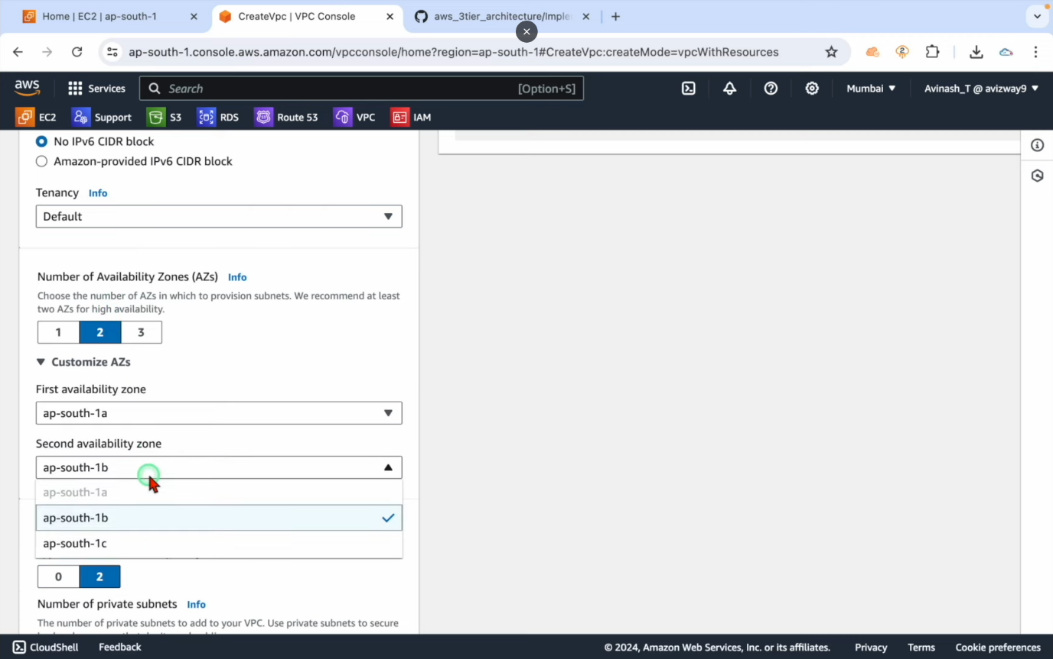

1. Now enter create VPC. The VPC will start executing with given settings.

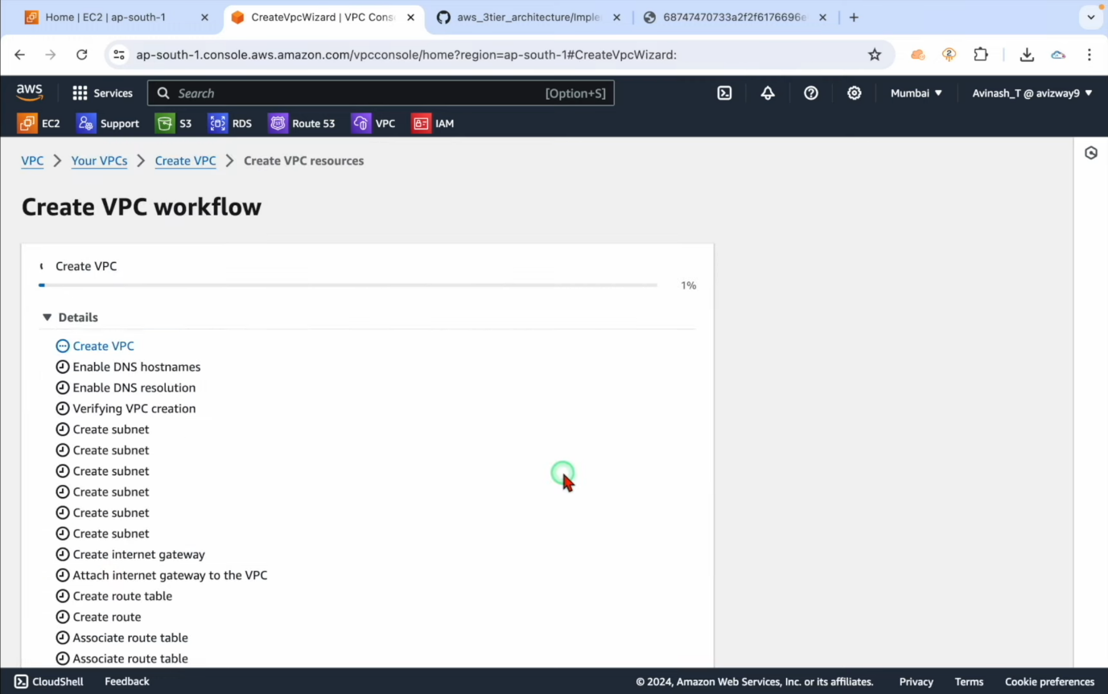

1. For databases, create a S3Bucket.

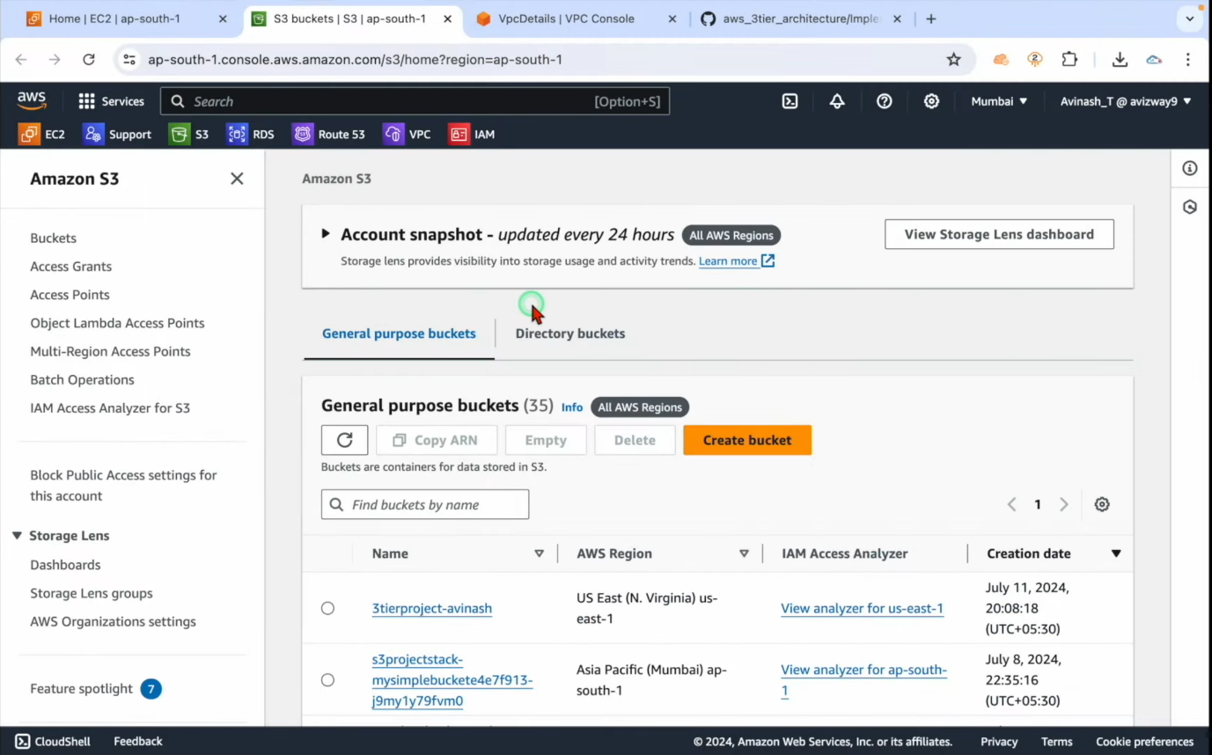

1. After the S3 bucket is created upload the files for application code that is created.

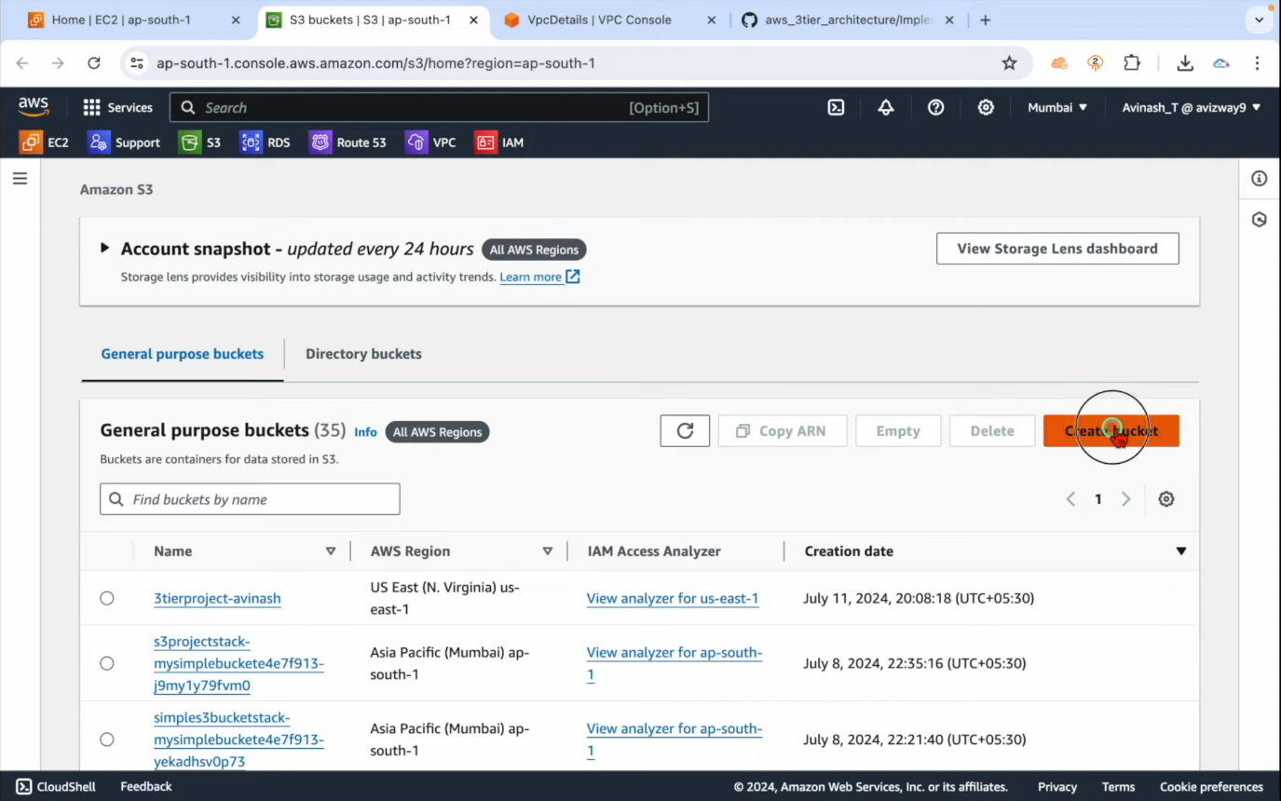

1. Drag and drop the application patches into S3 bucket.

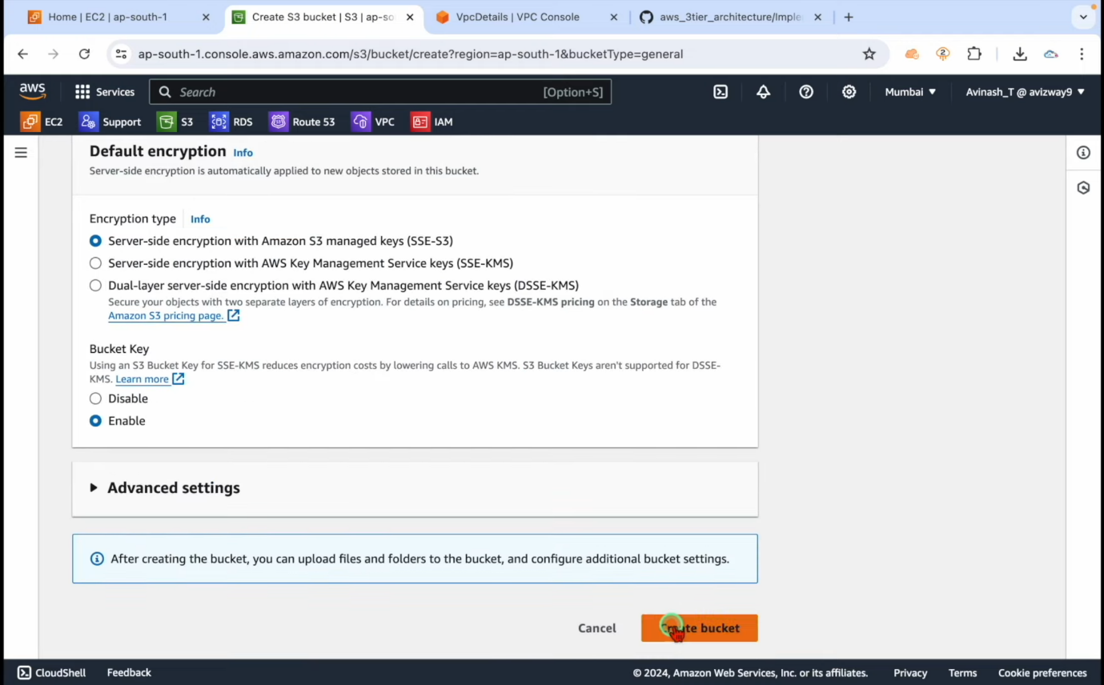

1. After the upload is finished, we need a web tier segment.

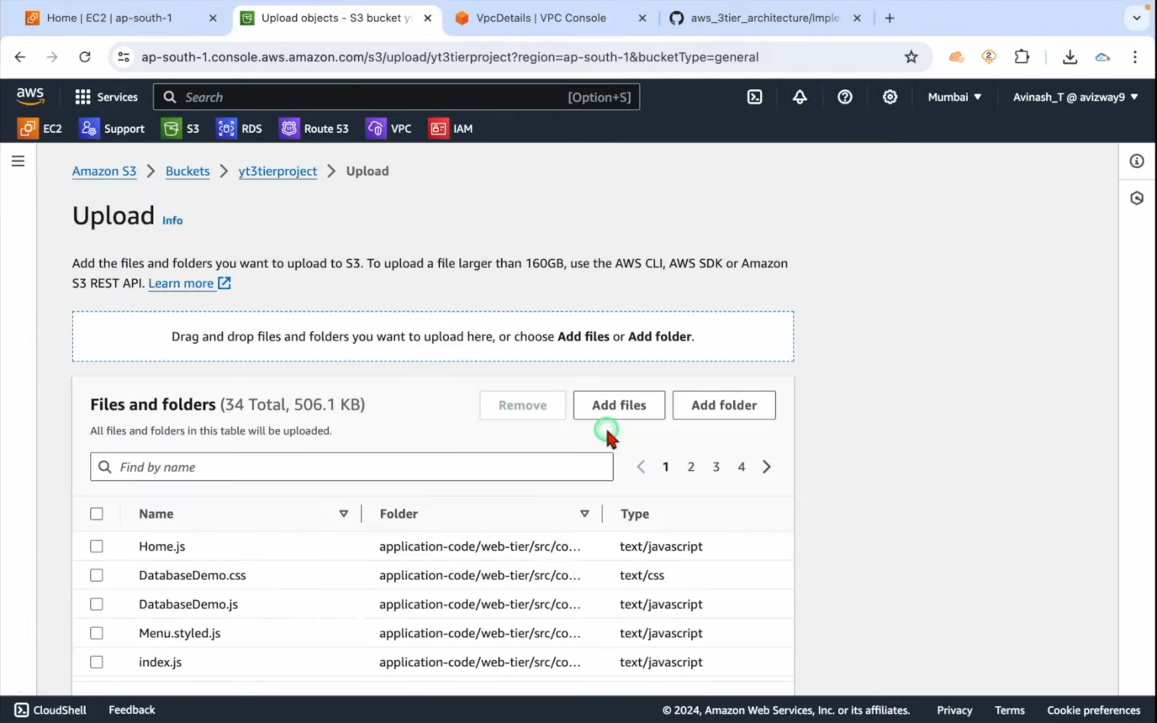

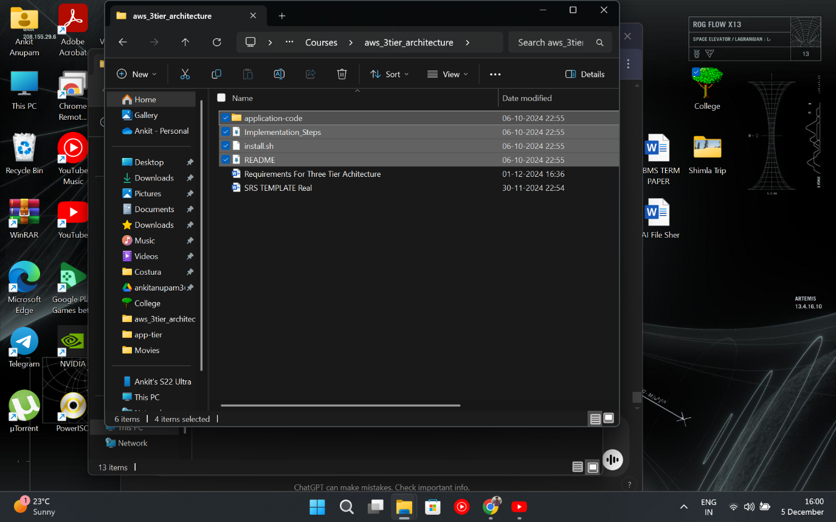

1. Now use SSM system service manager to directly link your web tier to app tier.

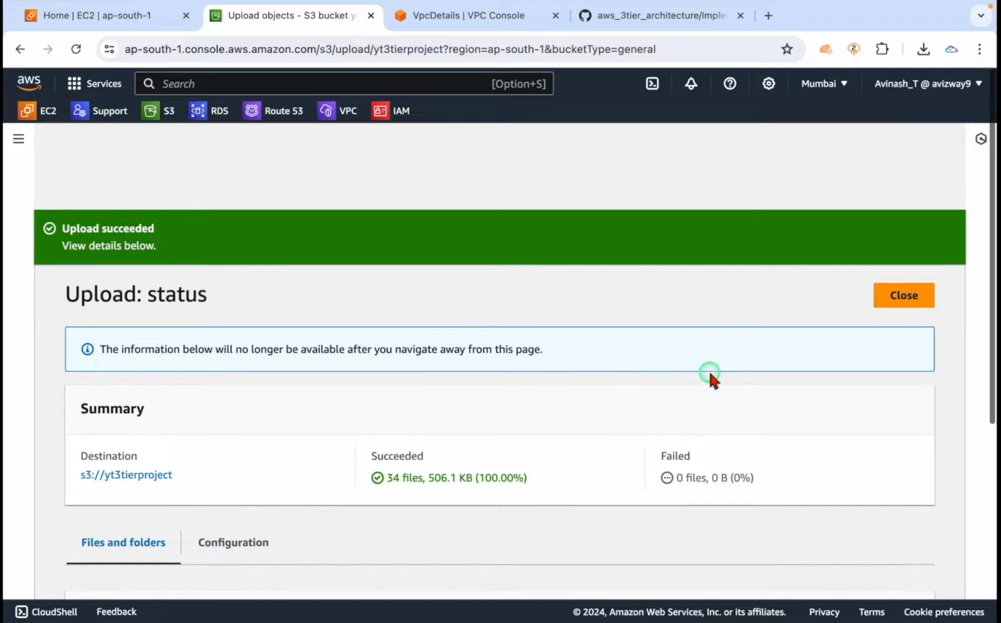

1. Navigate to IAM identify and access management Create Rules in the left navigation toolbar.

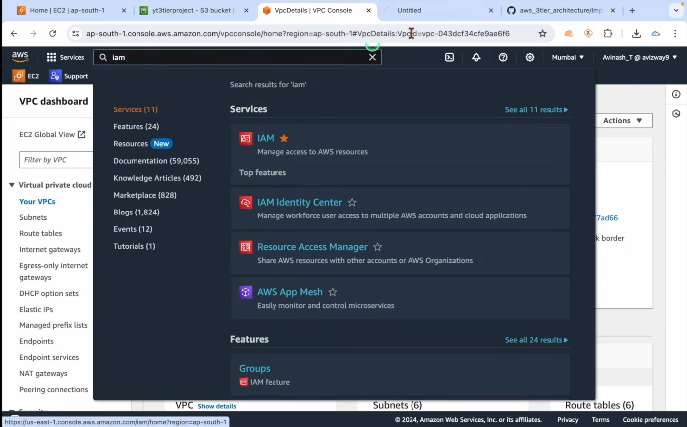

1. Select AWS service and opt for EC2 services.

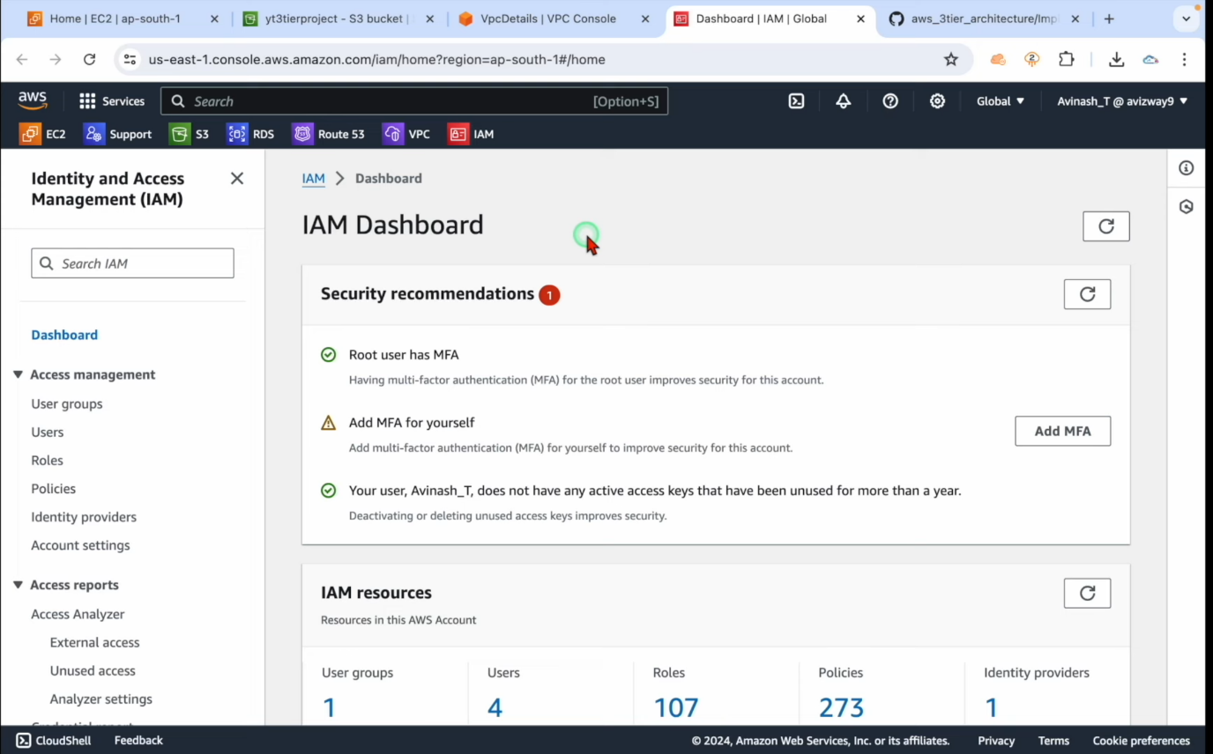

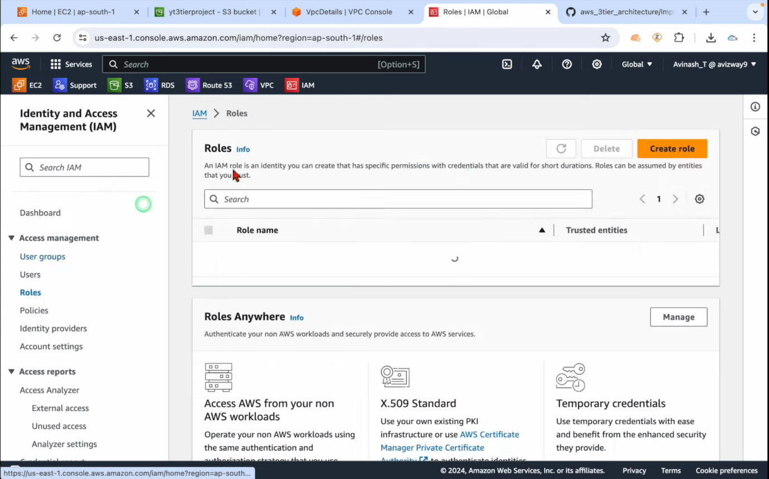

1. Add permissions in the IAM with rules; search SSM.

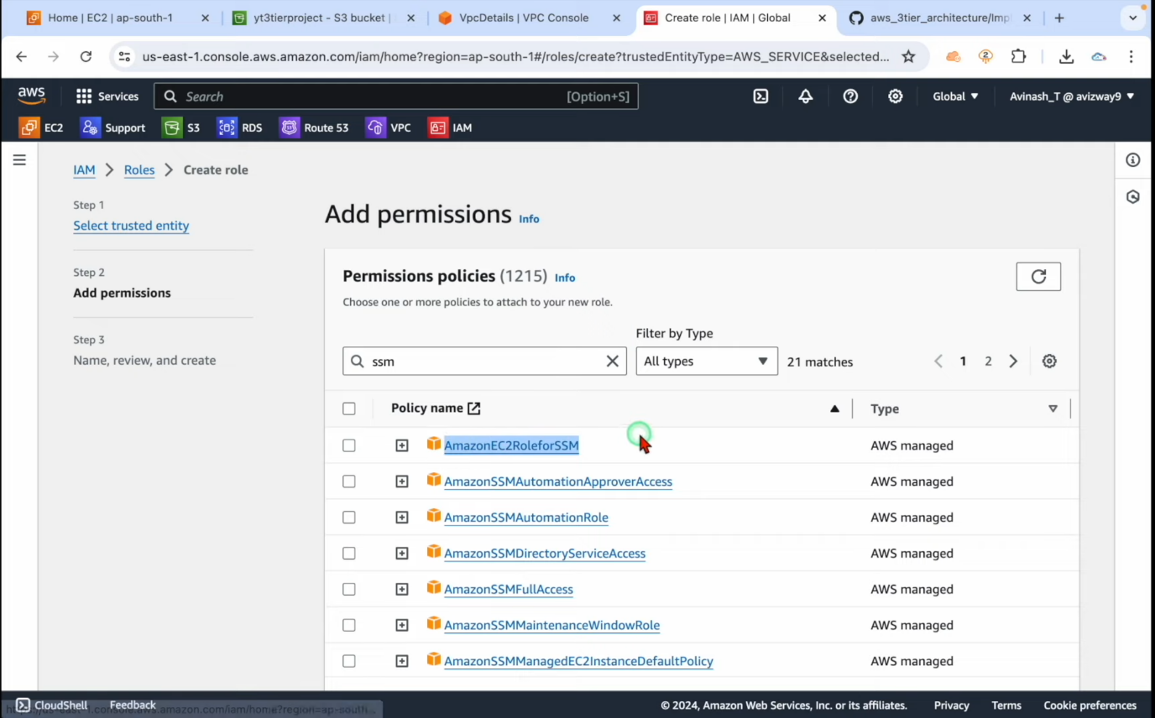

1. Name the rule which is to be assigned to the EC2 instance.

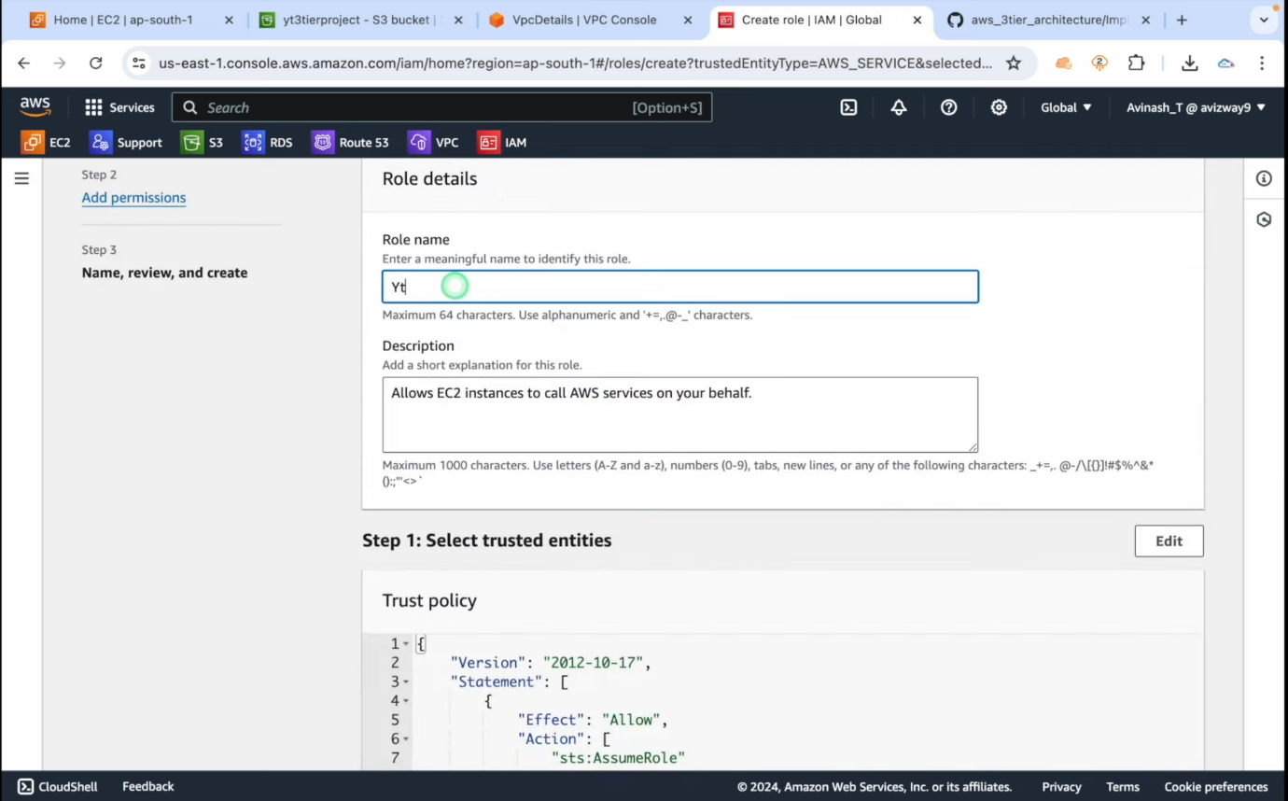

1. Now go to subnets to segregate the desired subnets into private and public subnets naming two subnets in apps and two subnets in DB.

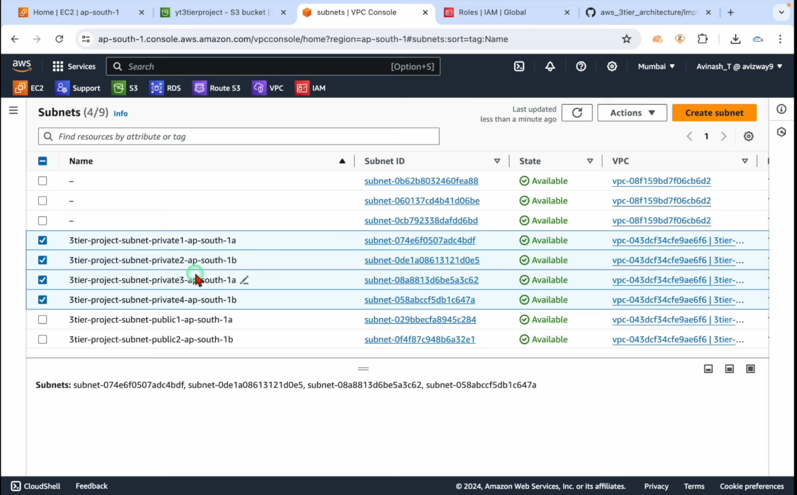

1. Now navigate to Amazon RDS and then on the left side toolbar get subnet groups.

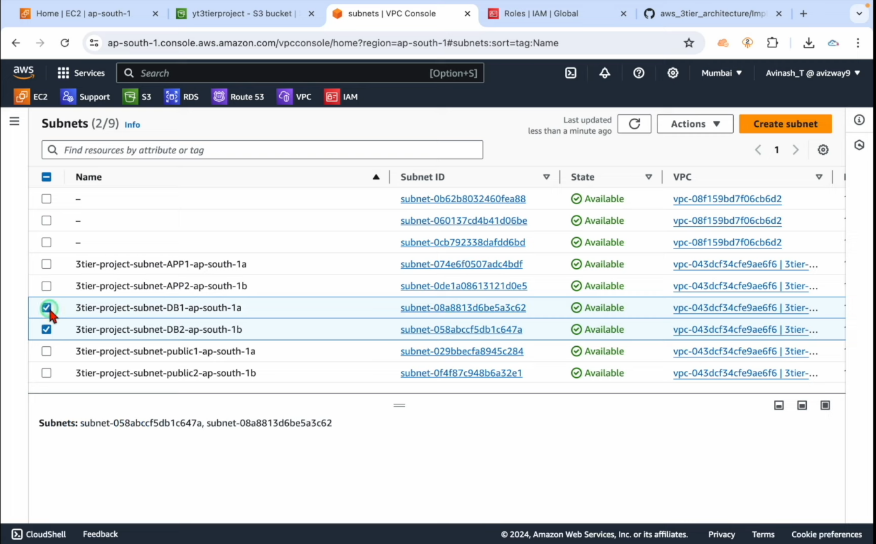

1. Creator db subnet group name the group choose the VPC to which it allocates. Check availability zones.

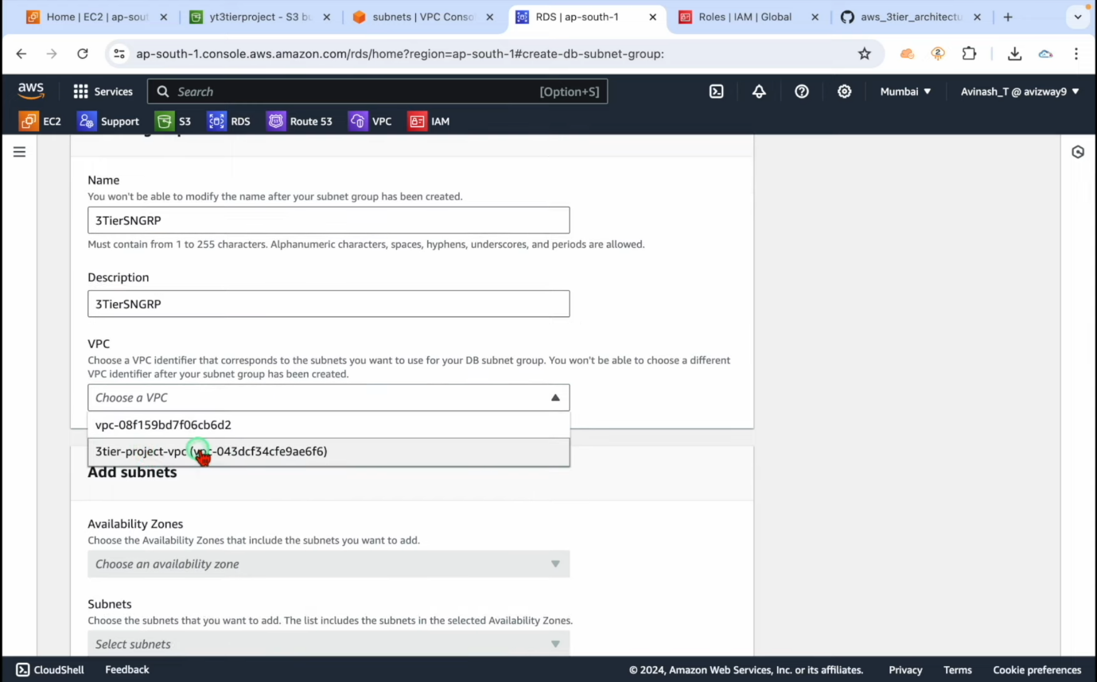

1. Allocate the subnet which must match the availability zones which were renamed earlier.

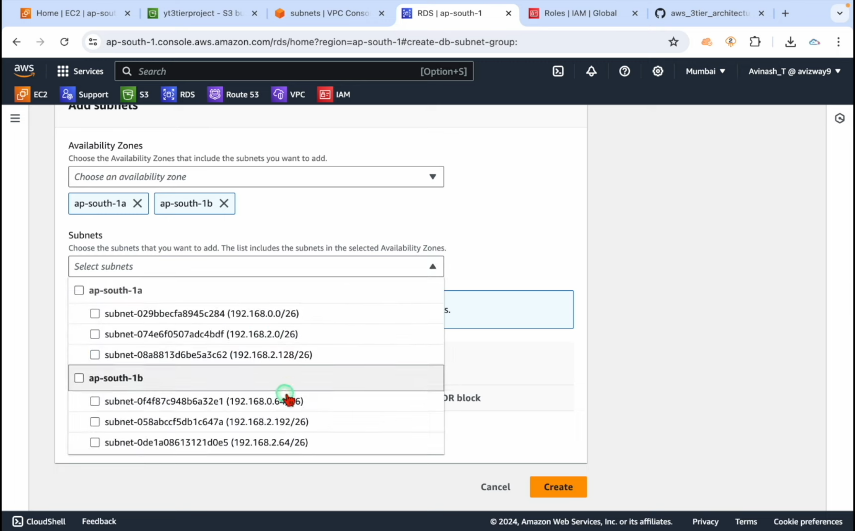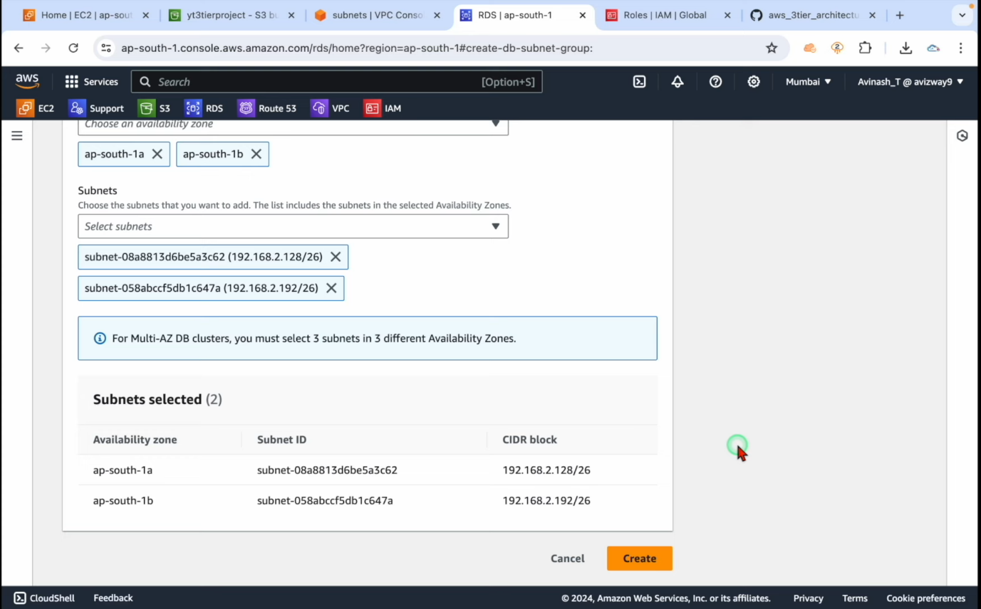

1. Now to create a rds database we are using mysql.

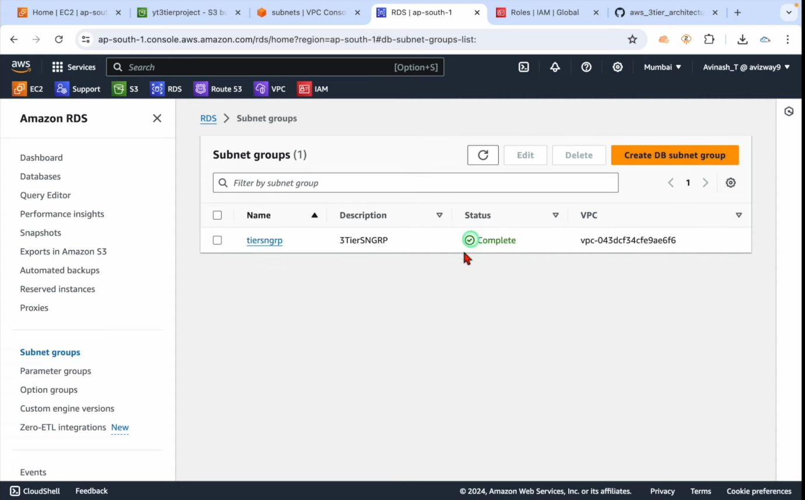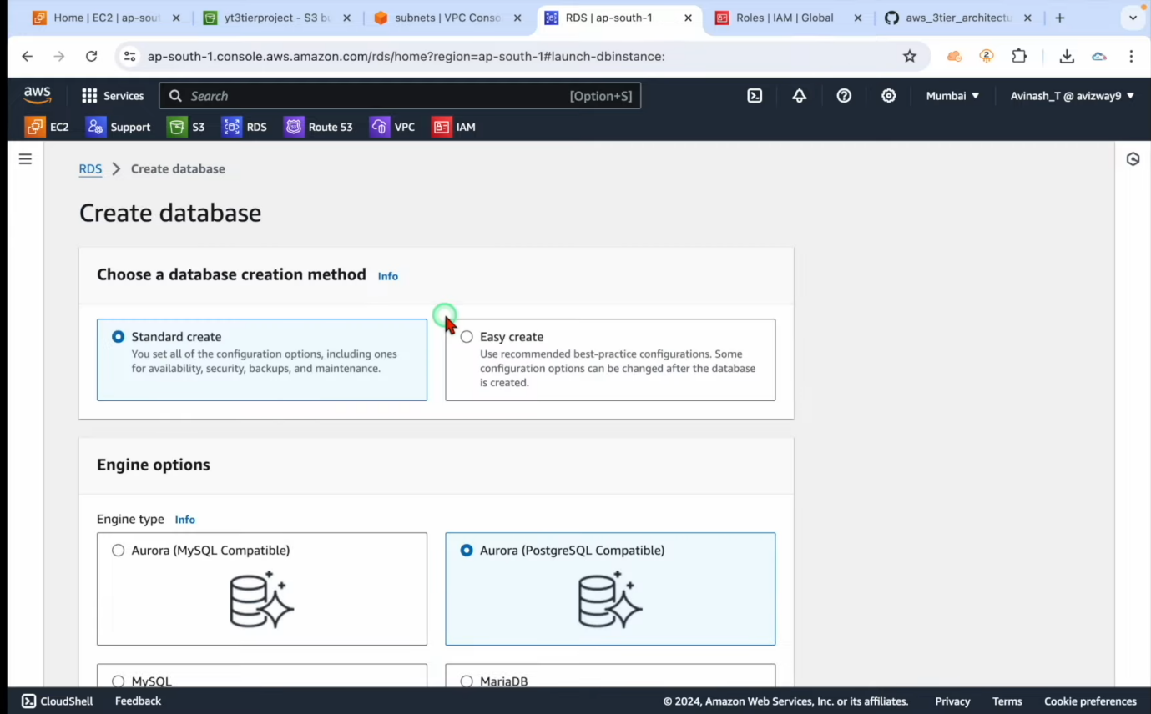

1. Navigate to database and select my SQL select standard create validate free tier. validate the latest SQL version. Credential settings and set username admin and create password save the password in a txt file format.

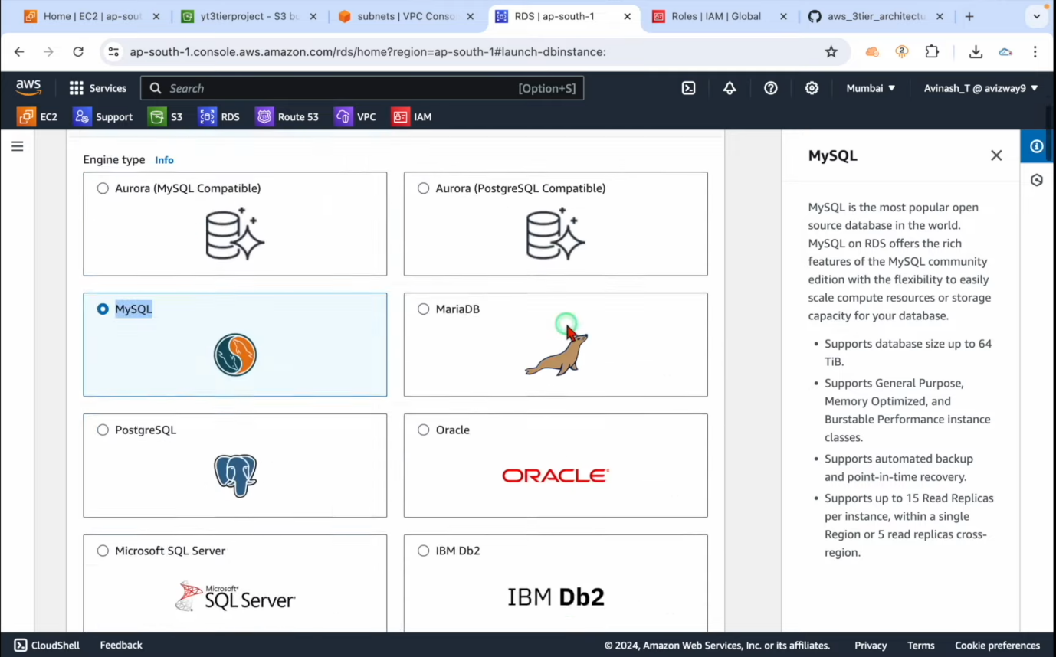

1. Check for all other availability zones. Head to connectivity then commute resource

Settings don’t connect to EC2.

Connect only IPV 4 protocol.

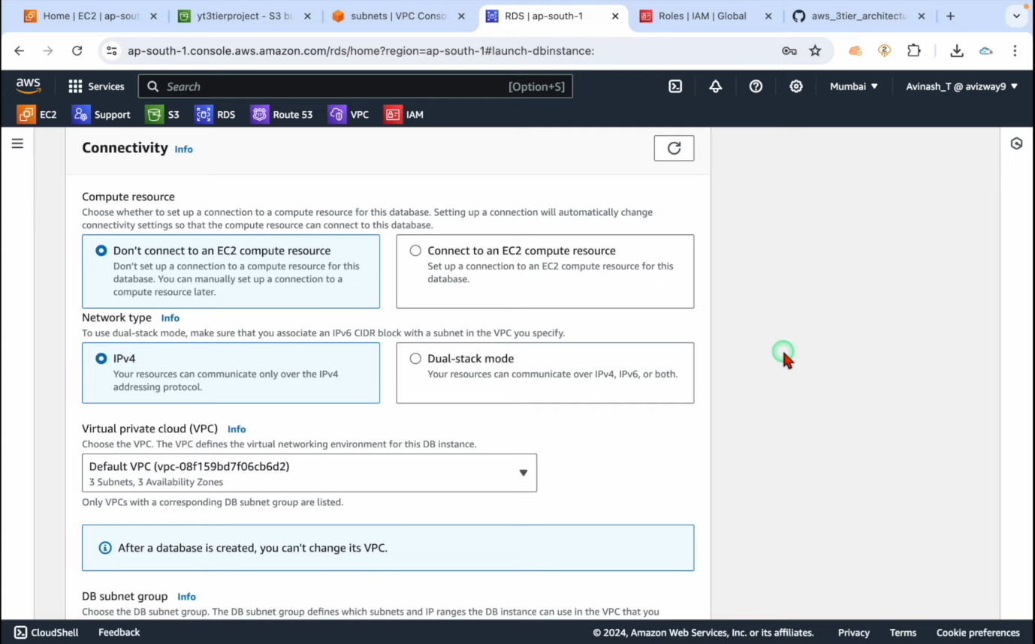

1. Now to traffic user base into database head to security groups.

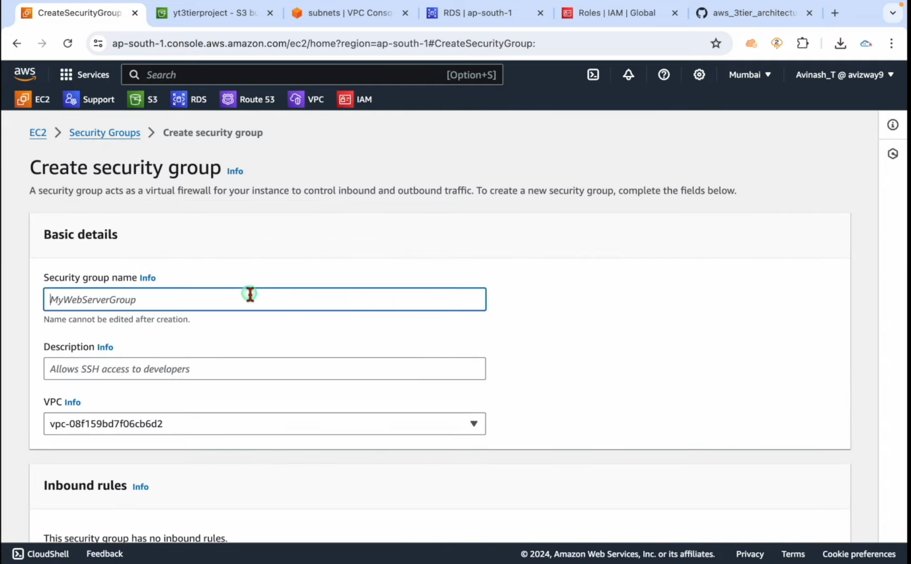

1. Name your security group and check which VPC will SG run.
2. Set inbound rules for which specific ips could you visit the hosting

Selecting type “my SQL”

Selecting source” designated IP”

And check box VPC CIDR.

And launch create security group. Also deny public access enable backups.

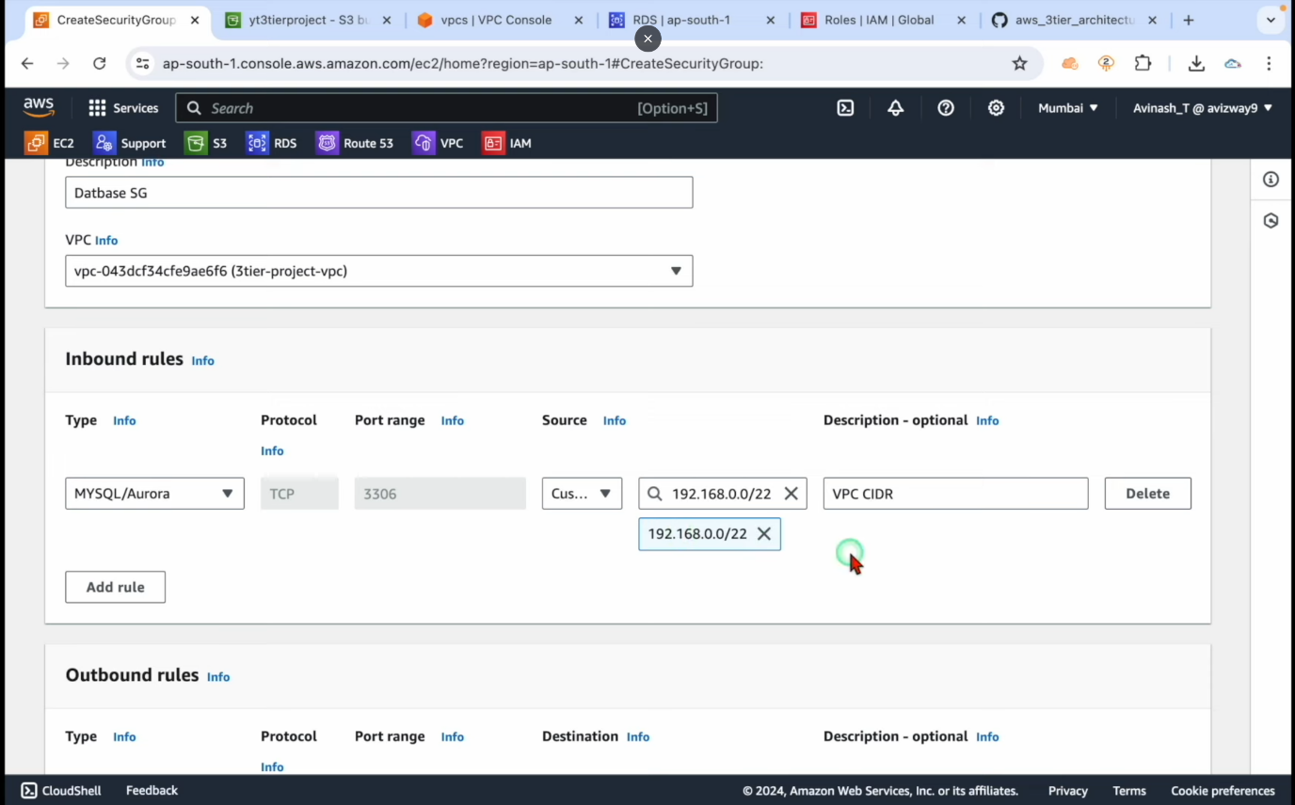

1. Now with the following steps. Create database now update the configuration in the database.

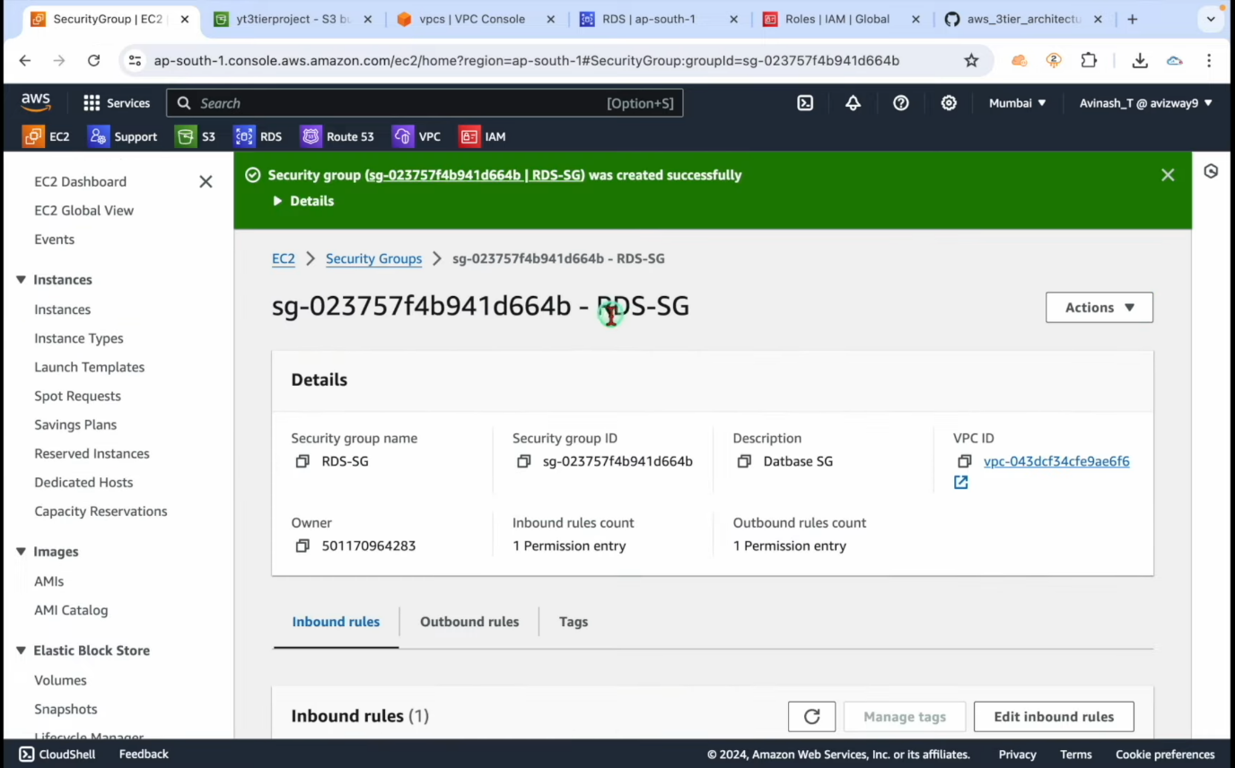

1. Till the database set is live, it create more security groups to allow traffic through other tiers.

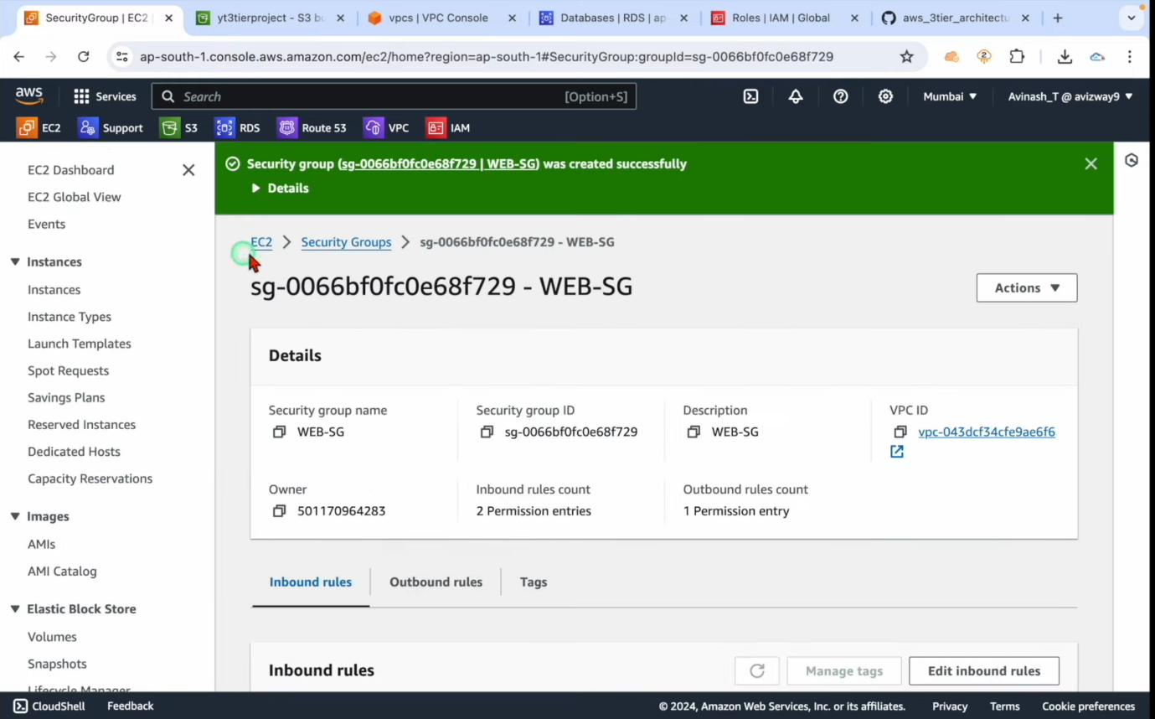

1. Now to create and attach all tiers and make a gateway to access all tiers we will create a load balancer ELB named it as apps.
2. Now allow traffic from HTTPS and HTTP sources into the security group and launch the security group.
3. Similarly create another security group for web tier name it web sg full top set inbound rules assign source from web alp created earlier in http.

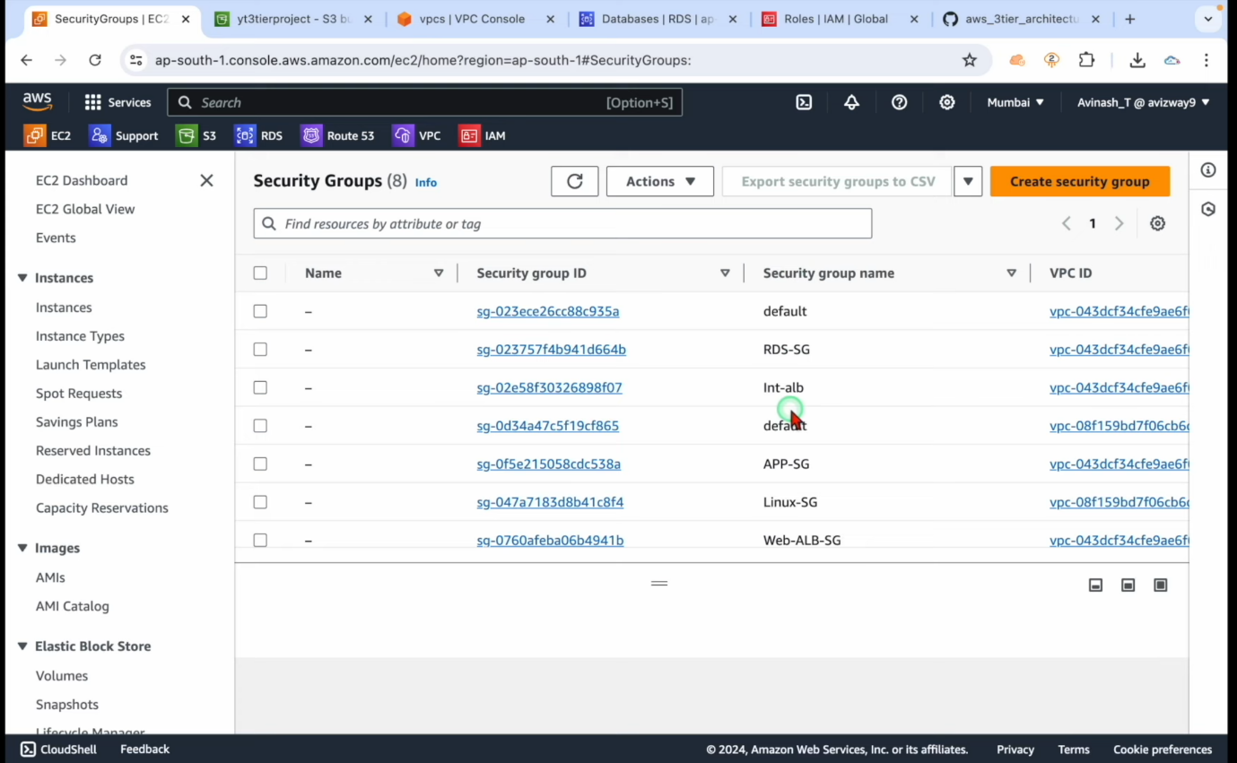

1. After your web security group is created create an app source from your assigned subnet id bracket including Cidr value
2. Create a load balancer security group to create gateway across the 3DS. Now all security groups has been created.
3. Meanwhile the database should have started and not connected by navigating to database and copying the endpoint port.
4. Copy the endpoint port and save it with the database credentials saved earlier together.

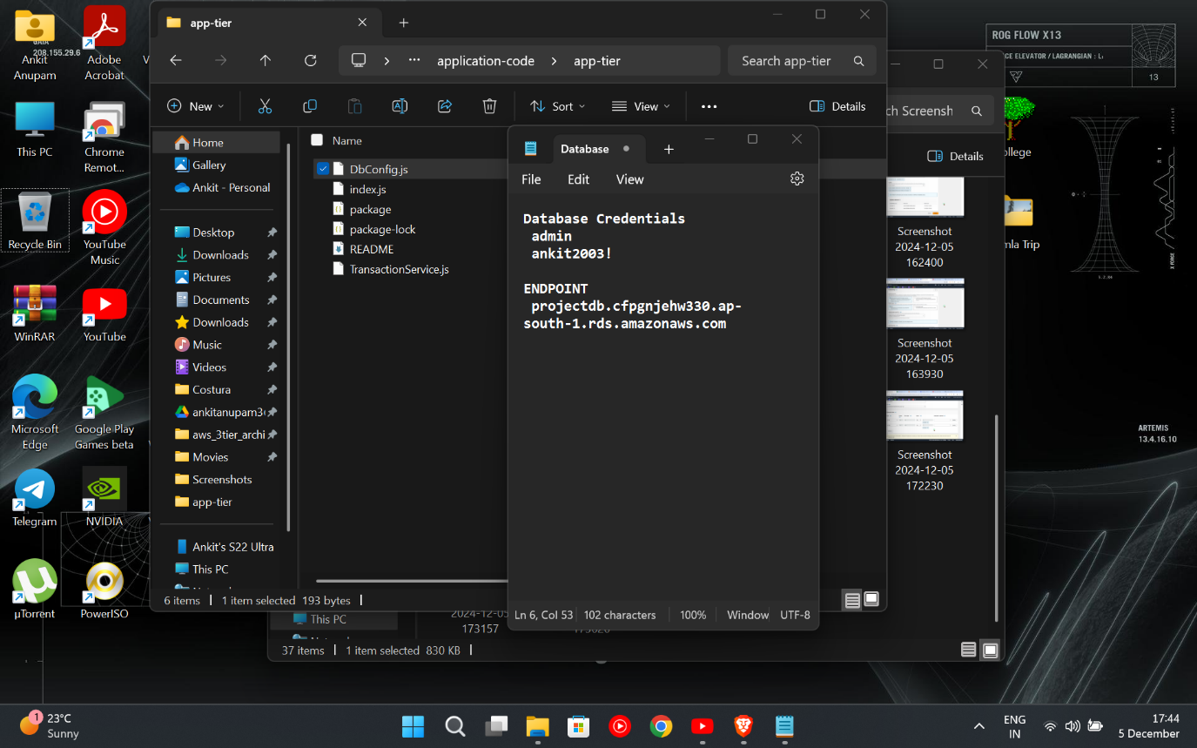

1. Update the credentials in app tier to connect off database.

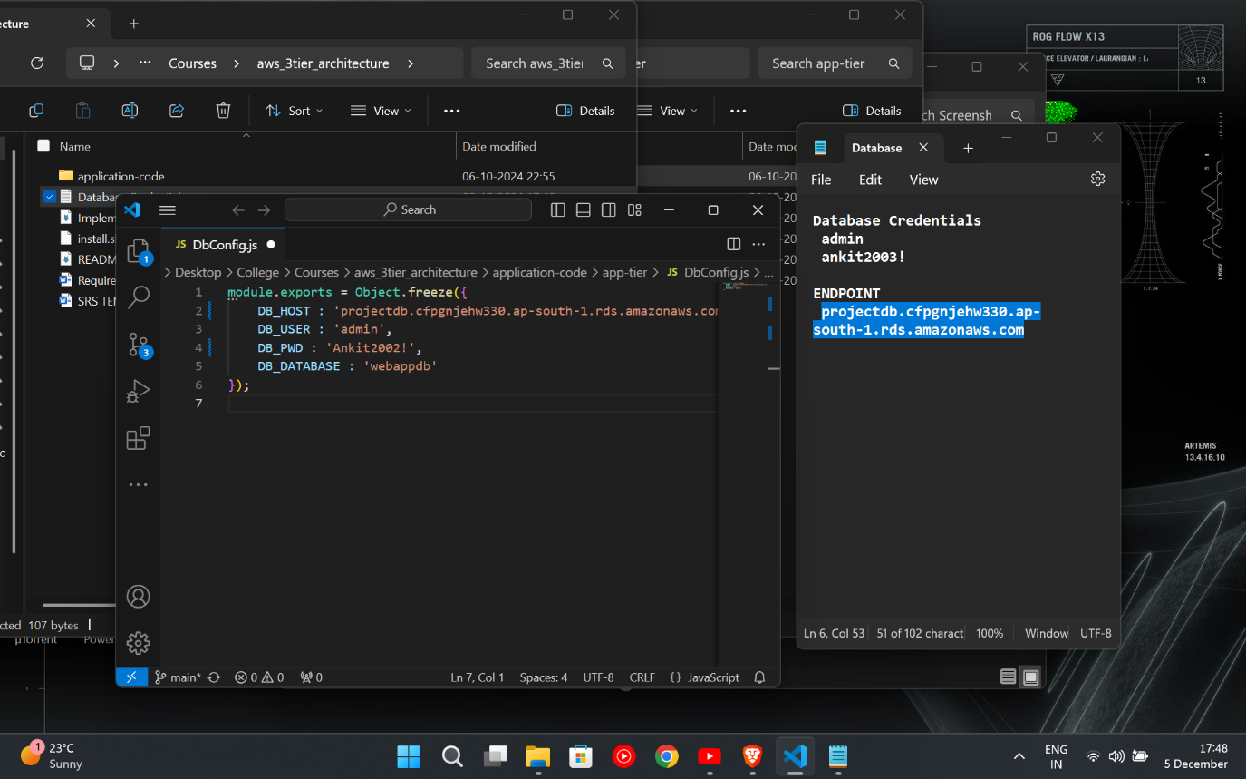

1. Update the database by navigating the database section and upload it to a new db file with updated credentials.

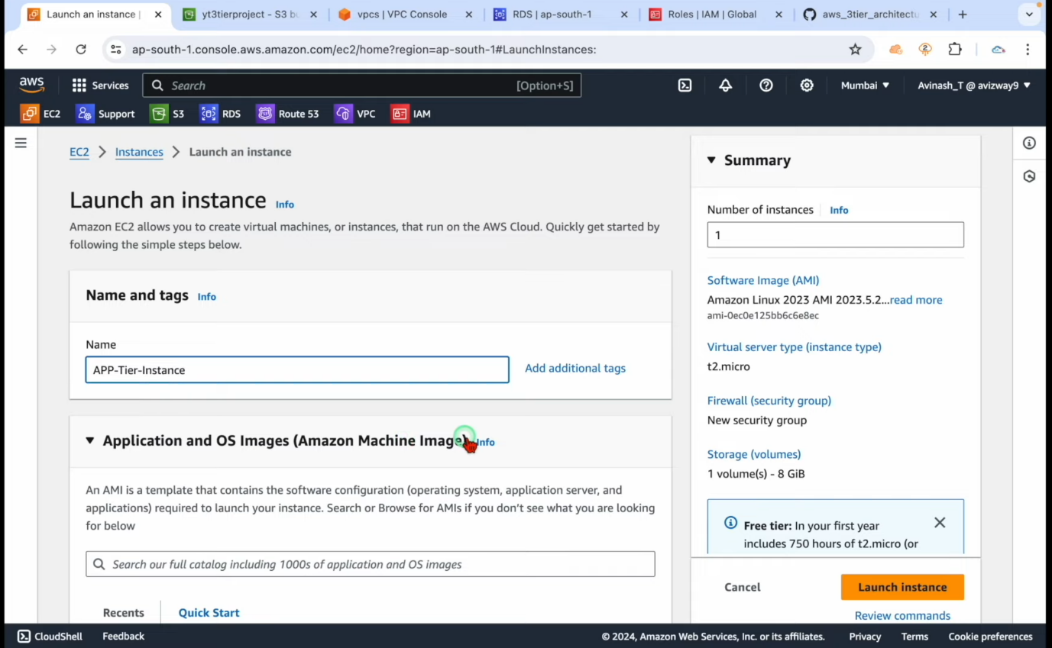

1. Create an instance with the app tier and choose the VPC which was primarily made. Select the app subnet in the subnet selection.

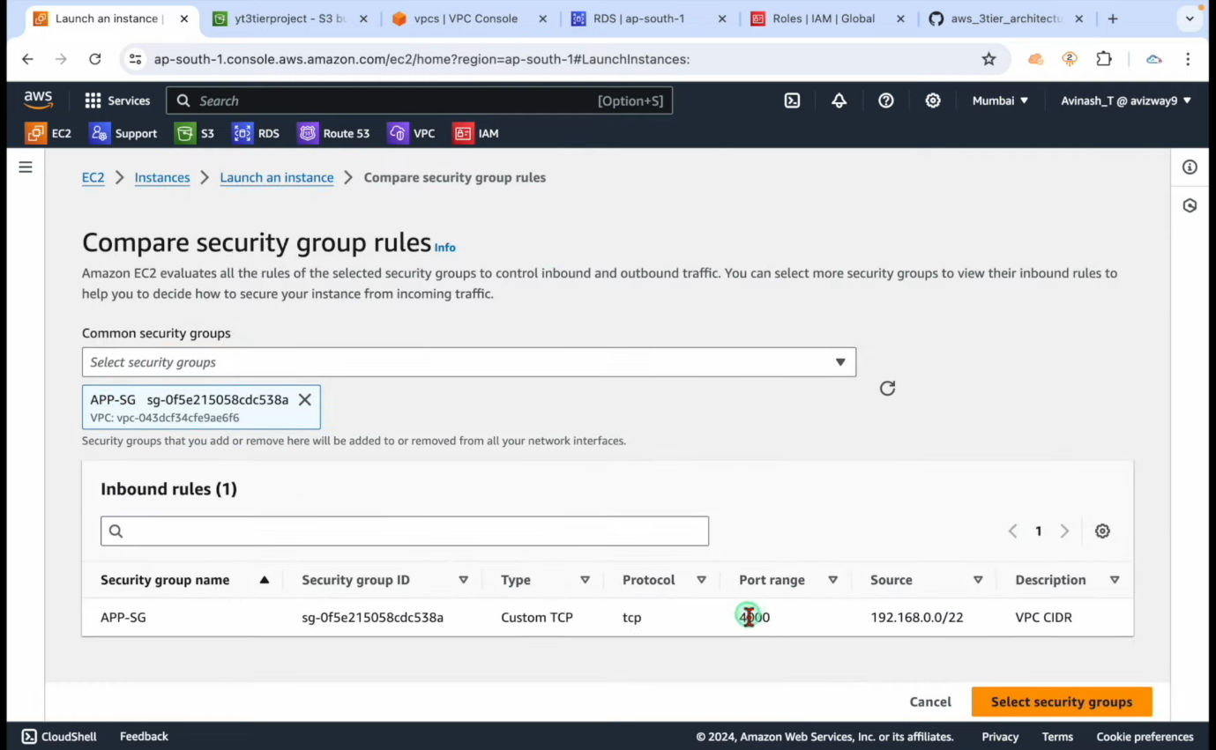

1. Now select existing security group as all the security groups have been created earlier and select the app sg in the options.

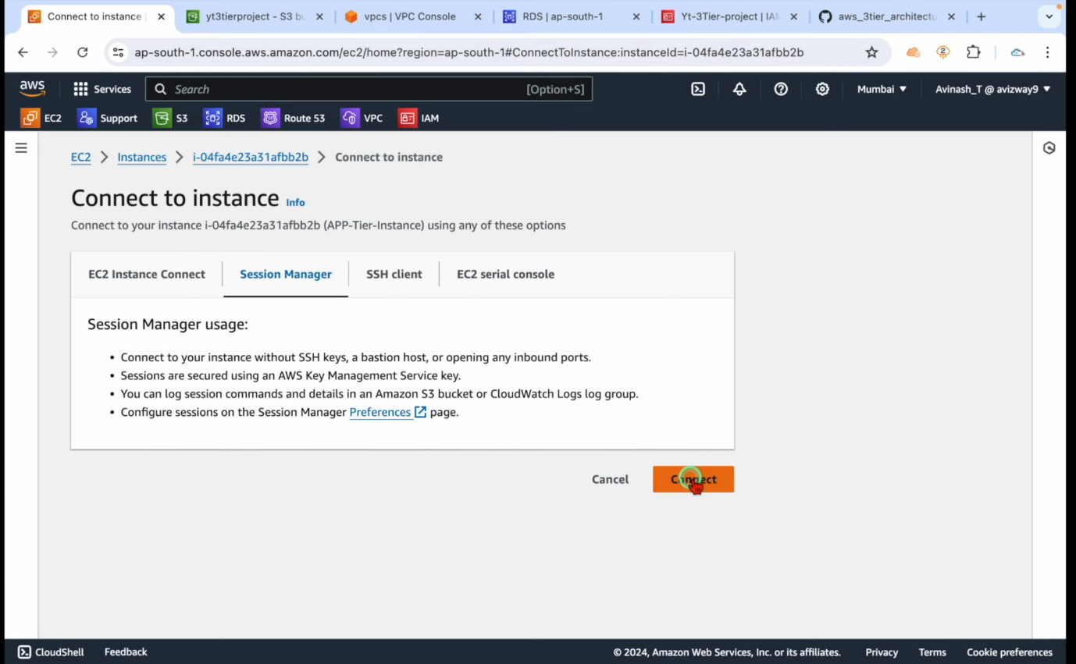

1. Also attach the IAM rule in EC2 instance in instance profile and launch the
2. Now install my SQL client before that connect to your created instance by session manager and click connect.

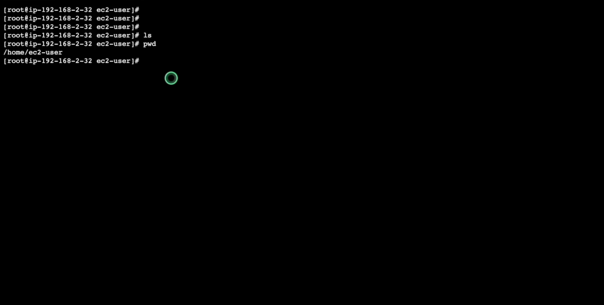

1. You will enter a Linux platform pseudo to attain all the main administrative rights and now you are connected to your EC2 instance next time.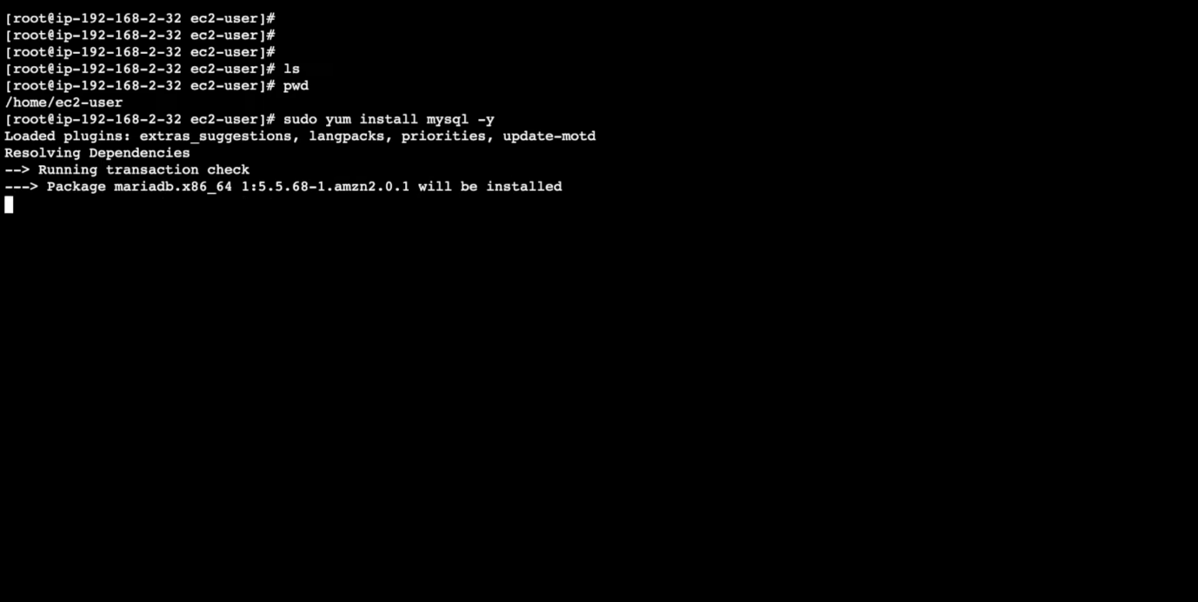
2. Within the platform install my SQL client with the provided script to install the client.

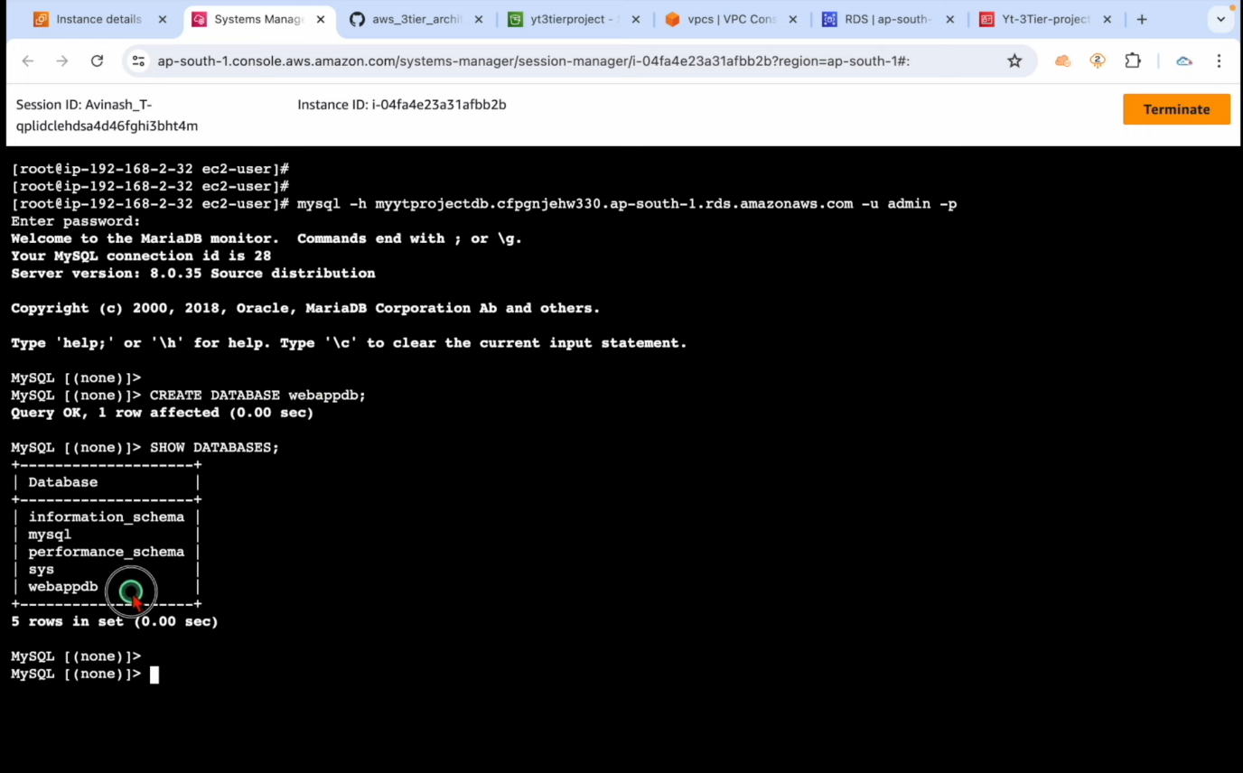

1. Now create database and execute show database creator database of your own choice in mysql or upload a schematic.

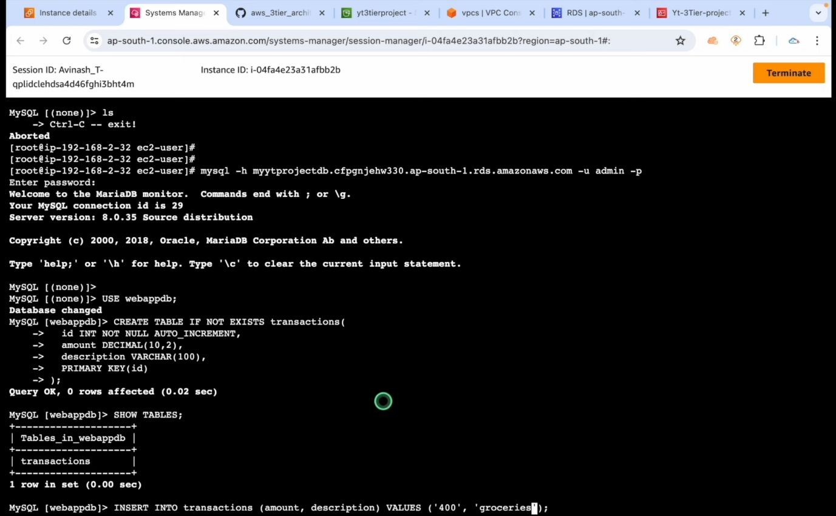

1. Add different rows and columns to the database and create the whole table with Linux commands.

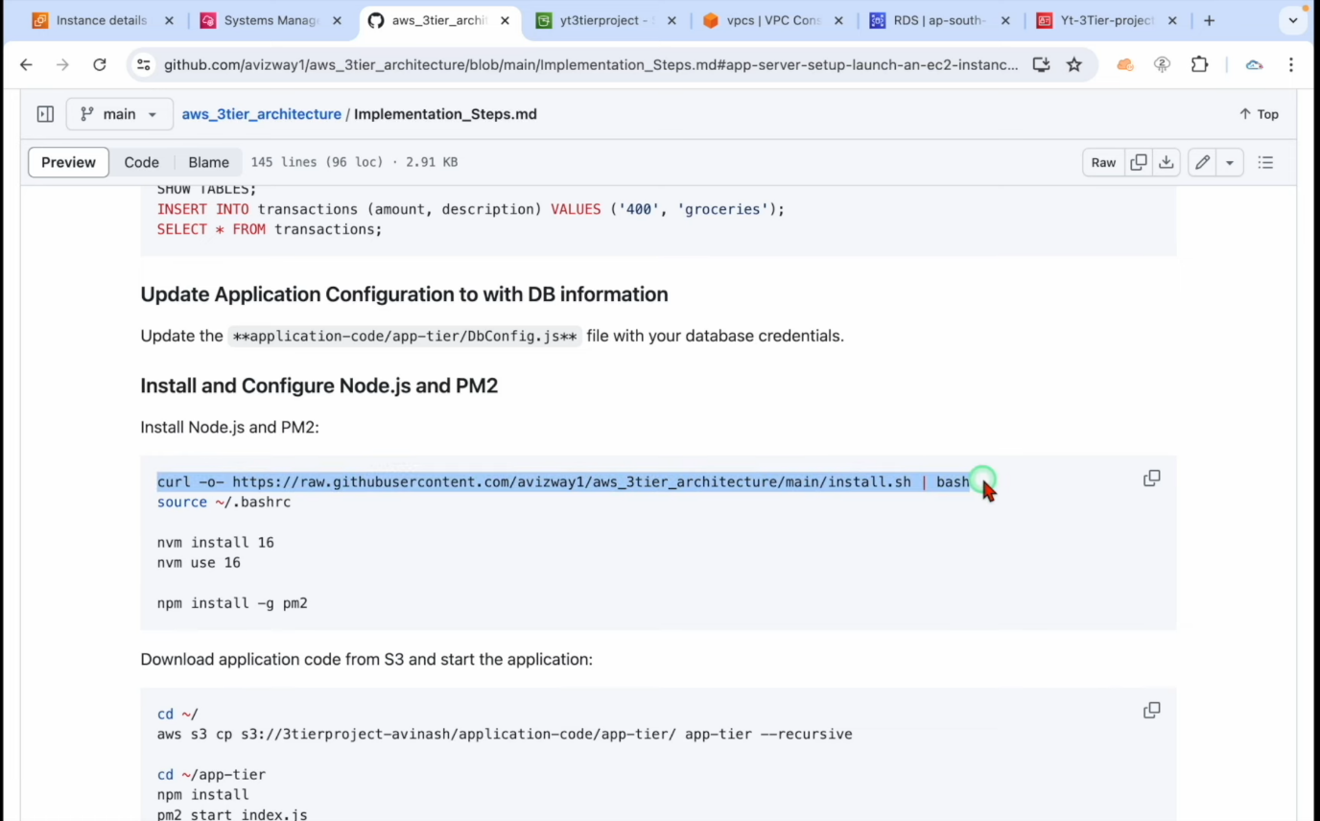

1. Now we will update the app configuration to DB information, now apply the script to the platform and download the application code within the DB.
2. Install NVM Node version manager into the client to manifest application data.

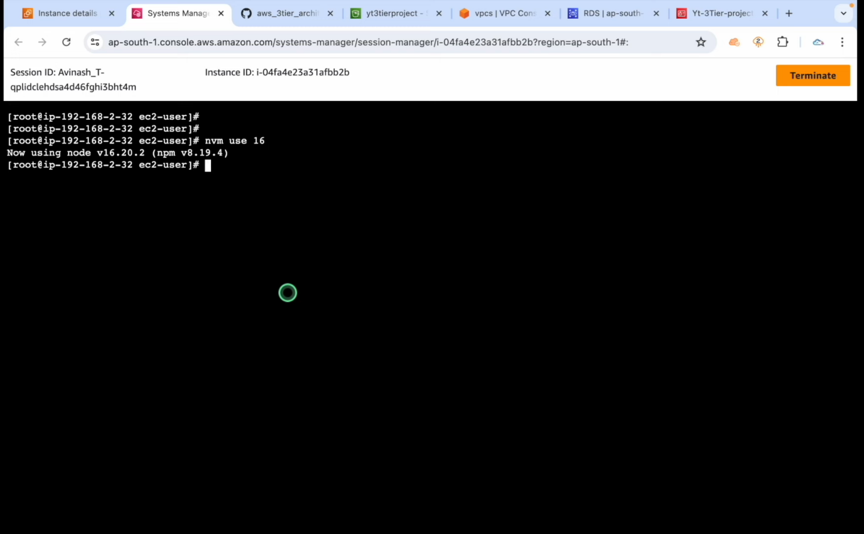

1. Install application indexes to the application tier and initiate node modules.

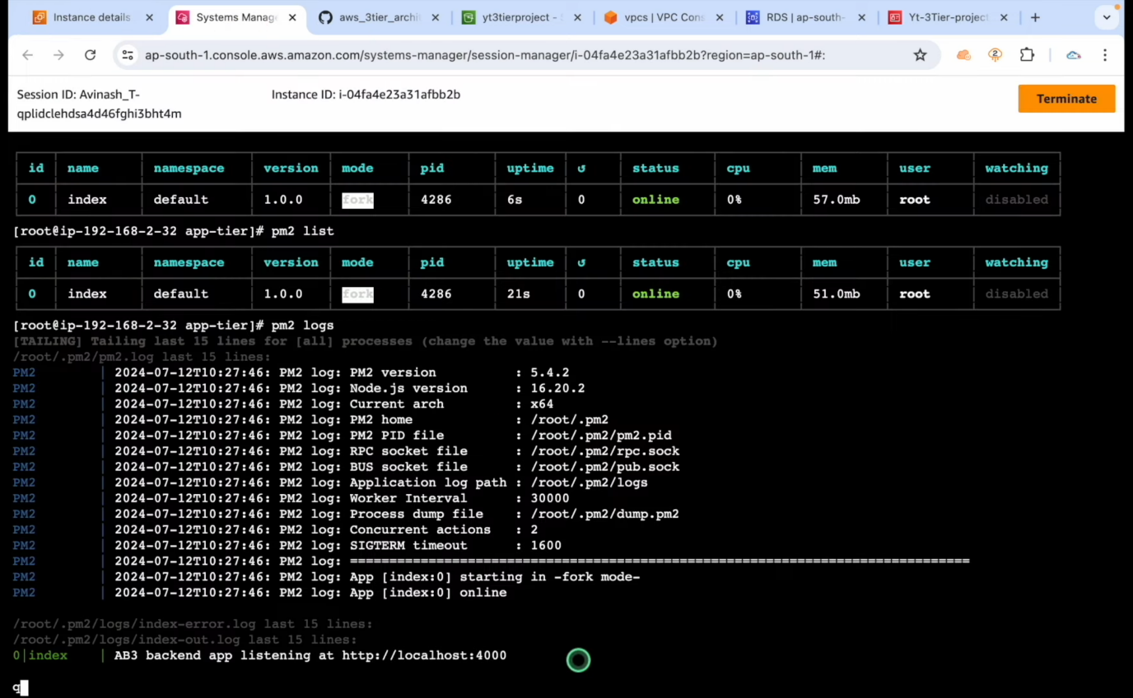

1. Now check node modules with the given script commands given in the list.

You can check various details pid status version CPU menu user and save the configuration.

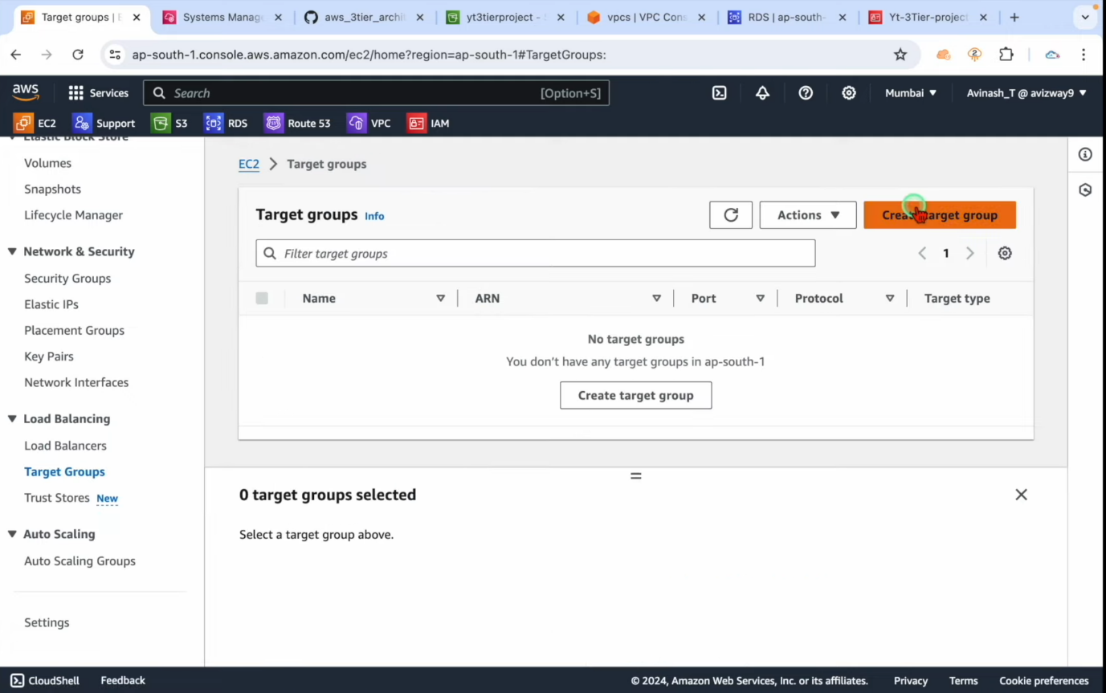

1. Now creator internal load balancer with adjusting auto scaling.

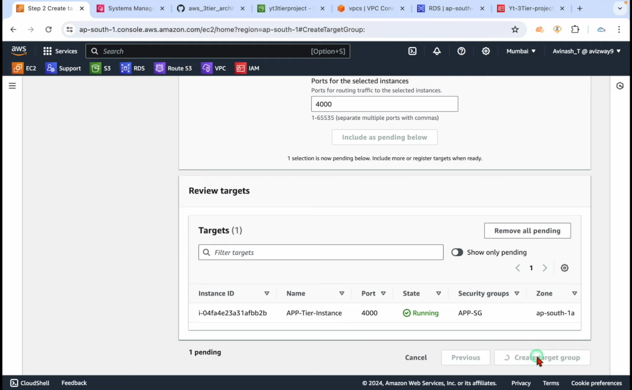

1. Now navigate to EC2 and target groups and create a Target group naming app internal load balancer with selecting the app VPC.

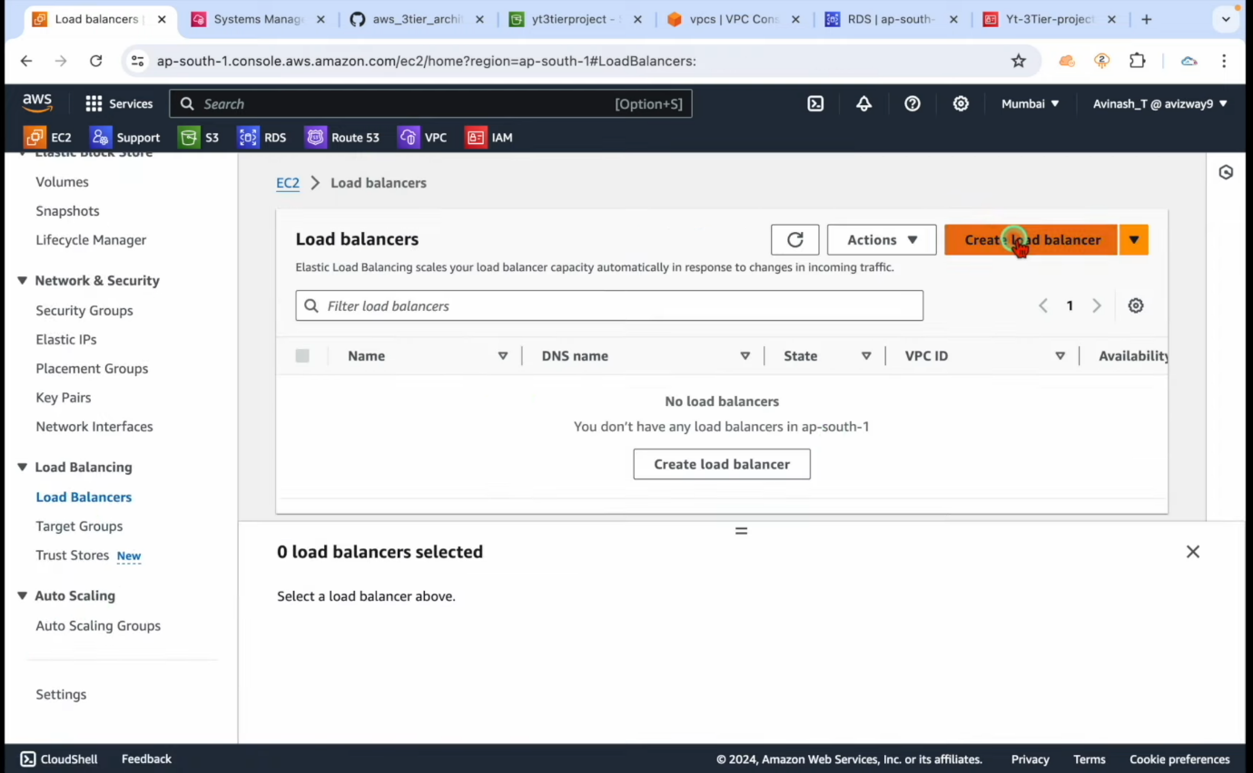

1. Now create a load balancer internal load balancer with the assigned subnet and choose security group for load balancer and launch.

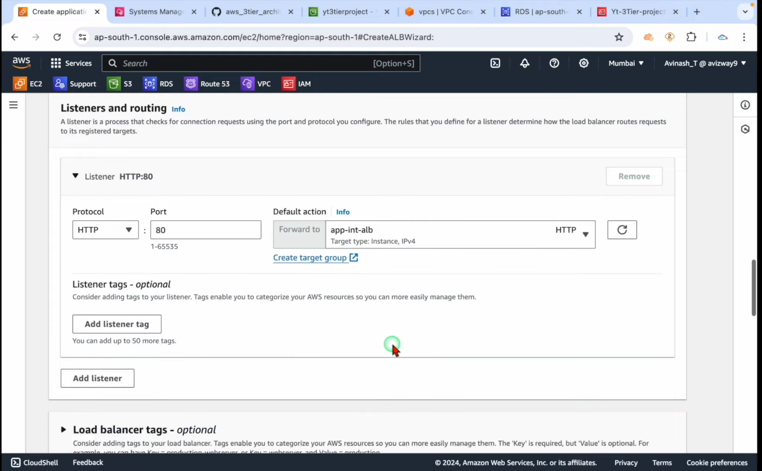

1. Now for the web tier we need to install NGIX with the given script in the report and apply for the node version manager.

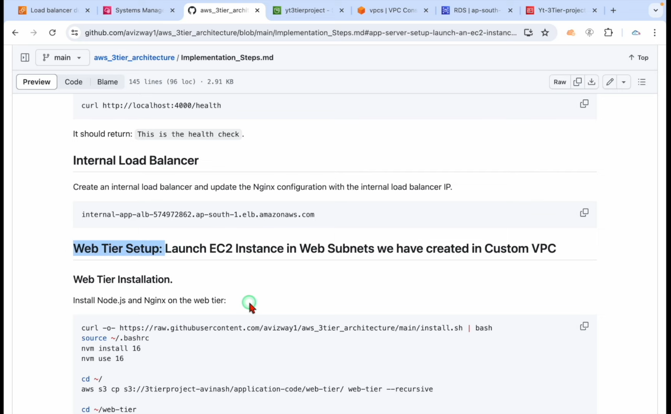

1. Create the Linux EC2 command in the instance and remember to select public subnet as it allows the incoming traffic to our web tie tier.



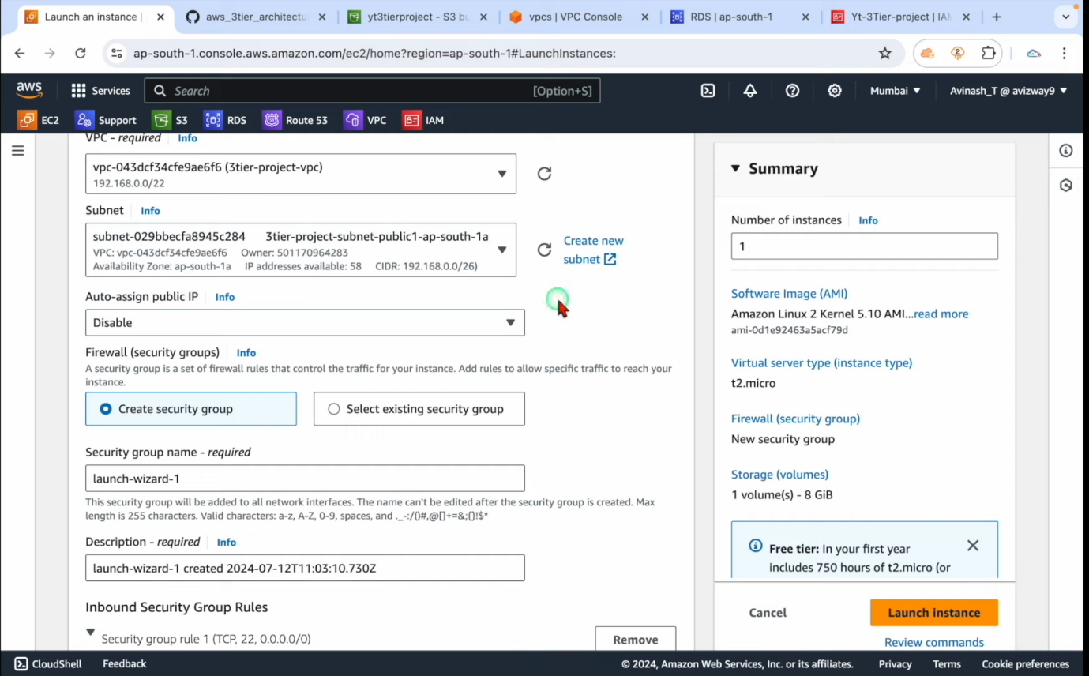

1. Now copy the allocated dns id to the Nginx text script mentioned in the report upload the new ng ins file into the application code.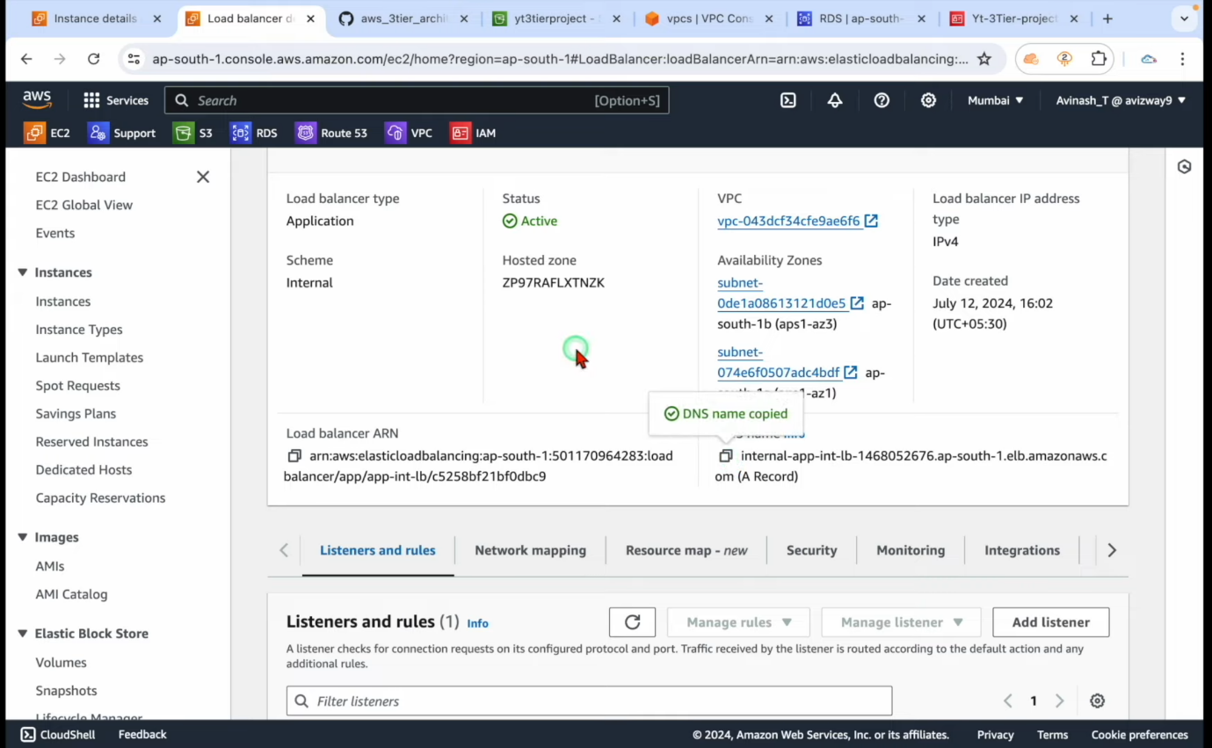
2. Now your load balancer is ready to synchronize.

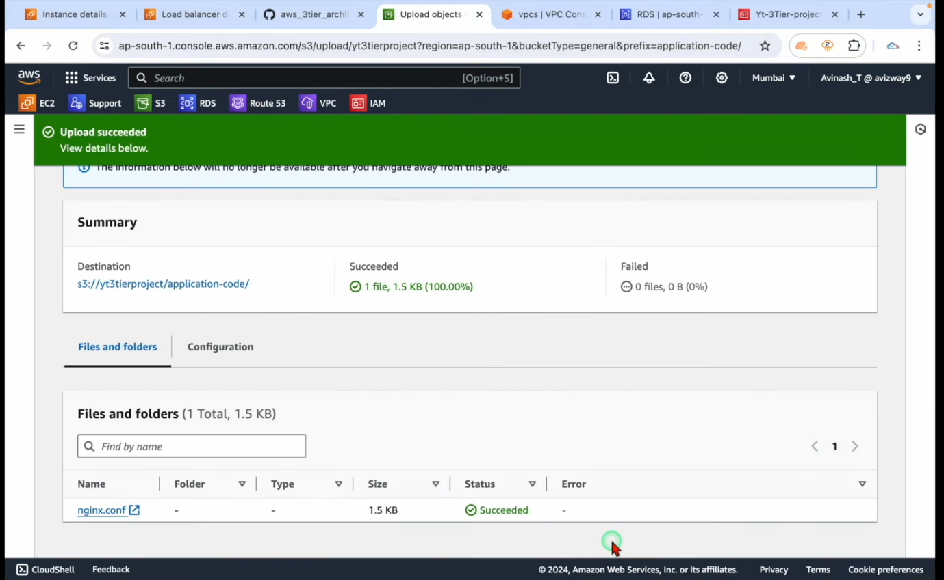

1. Now connect to instances by assigning roles into the platform and install NGINX into the web tier.

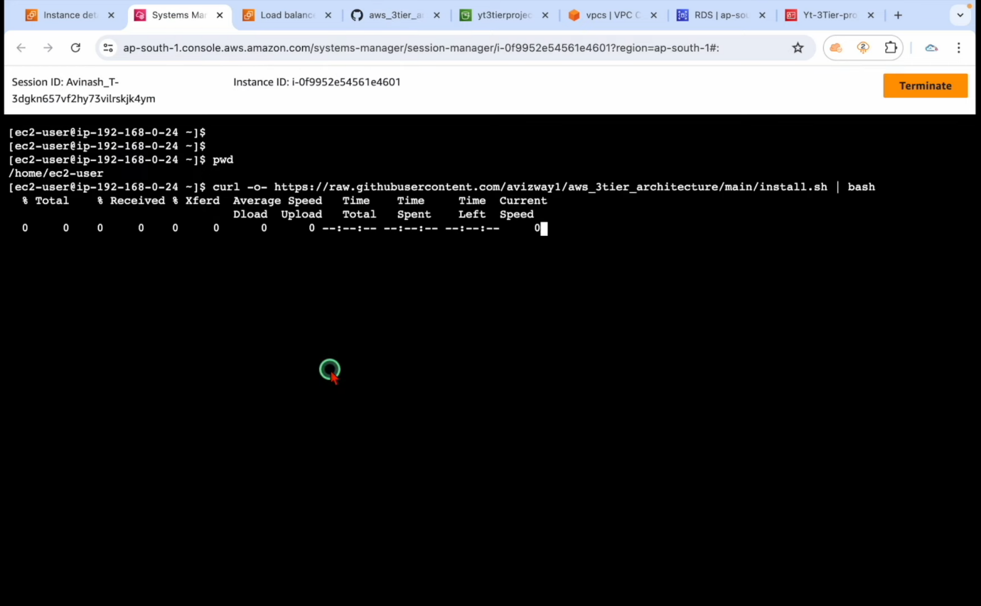

1. Combine the S3 bucket URL and paste to Linux for the web tier and run NPM protocol.

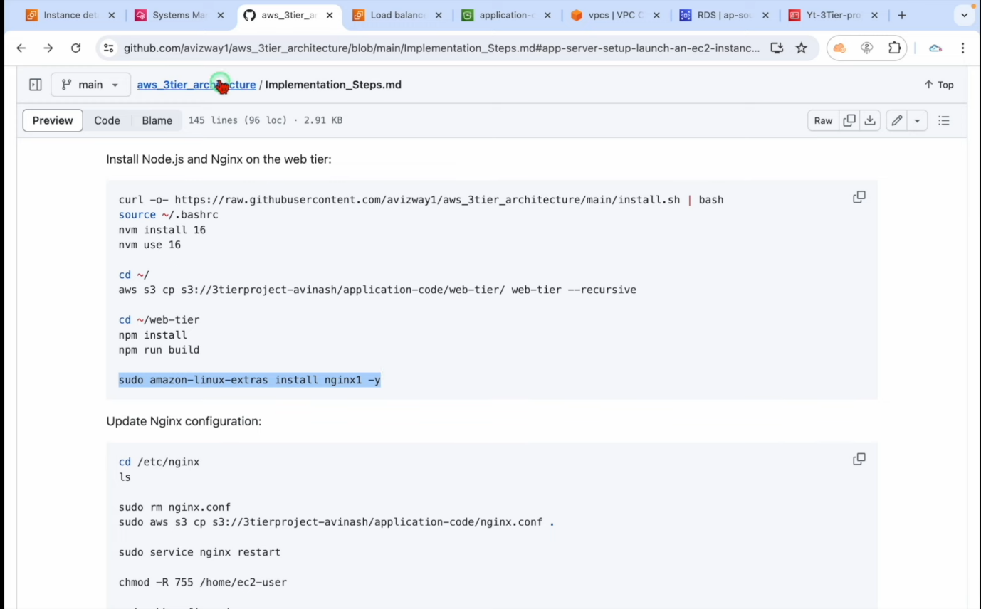

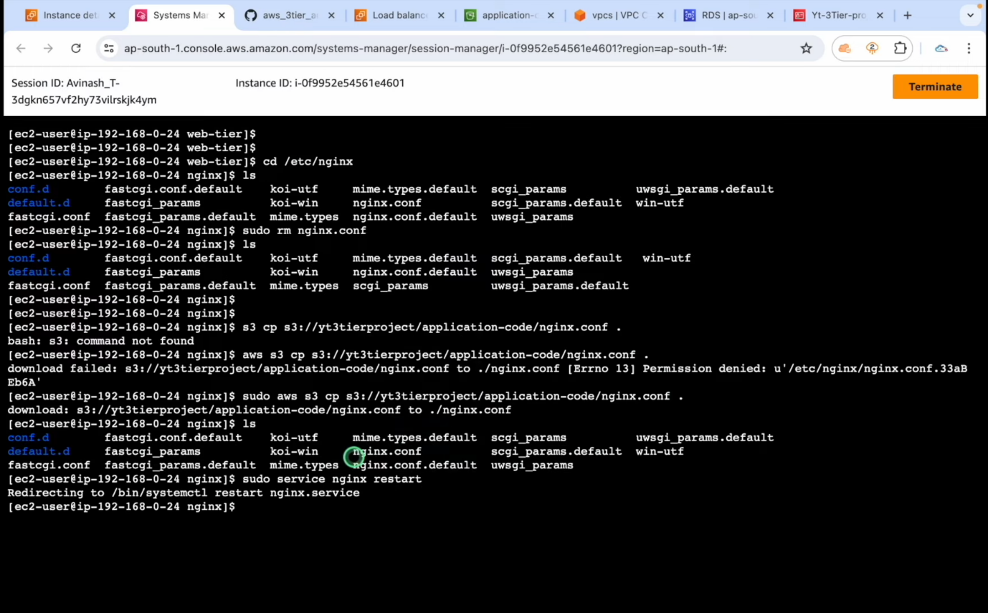

1. To run the instances and check the webpage we copy the IP addresses for that allow a native security group with existing key pair and allow http traffic.

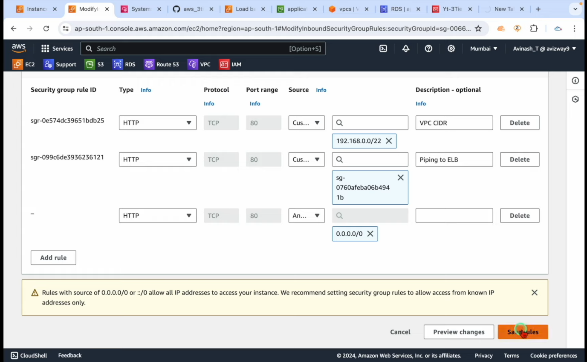

1. Copy the IP and run into your browser.

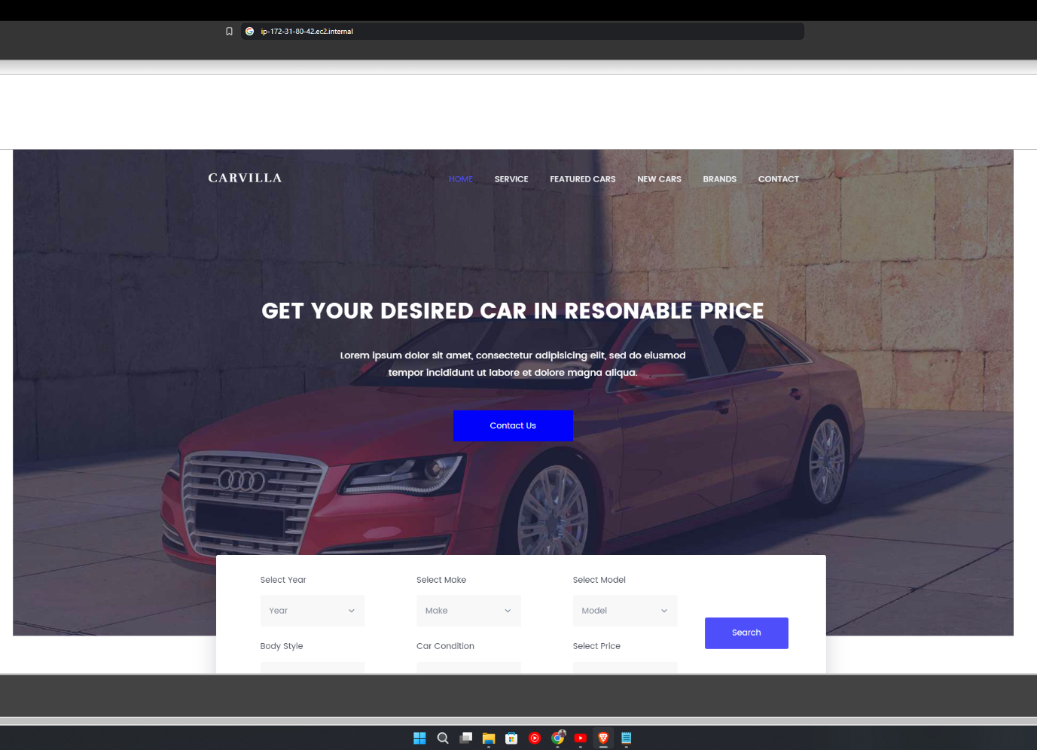

1. Your Three-Tier architecture is ready for deployment with a static application.